CLOUD COMPUTING

TASK 10.1P

Breaking a Monolithic Node.js Application into Microservices

**Task 1: Preparing the Development Environment**

**Objective**: Get your workspace ready in the AWS Cloud9 IDE.

**Subtasks:**

* Open Cloud9 using the provided URL.
* Use curl to download a tar file containing 3 versions of the app:
  1. **1-no-container**: monolithic app (runs locally).
  2. **2-containerized-monolith**: same app made ready for Docker.
  3. **3-containerized-microservices**: refactored into microservices.
* Keep this IDE open for the entire lab.

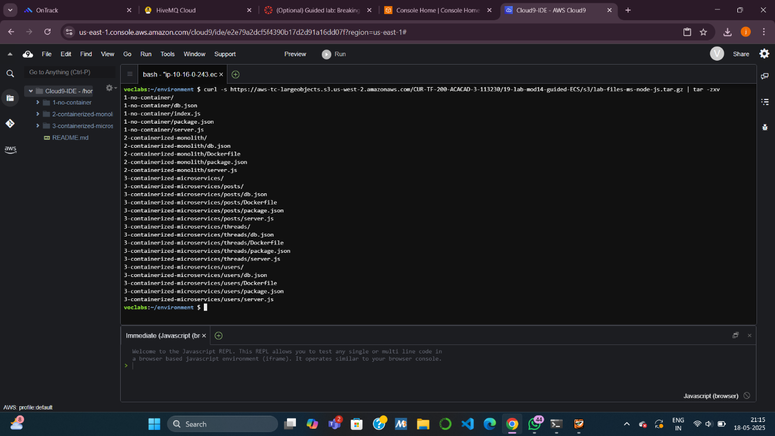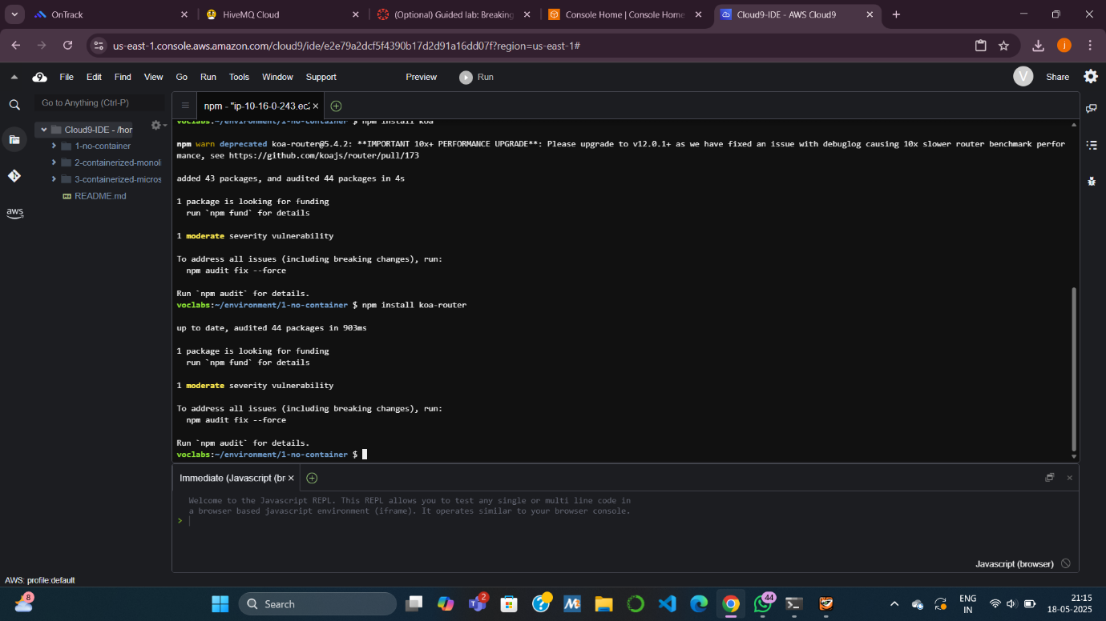

**Task 2: Running the Application on a Basic Node.js Server**

**Objective**: Understand and run the **monolithic** version without Docker.

**Subtasks:**

* **2.1 Install dependencies**: Install koa and koa-router with npm.
* **2.2 Review code**:
  + index.js: sets up cluster mode (1 leader, 1 worker per CPU core).
  + server.js: contains all REST APIs (users, threads, posts).
  + db.json: mock database of users, threads, and posts.
* **2.3 Run and test app**:
  + Run using npm start.
  + Use curl to call APIs like /api/users, /api/threads.
  + Observe logs to understand request flow and timing.
  + Stop the server using Ctrl+C.
* 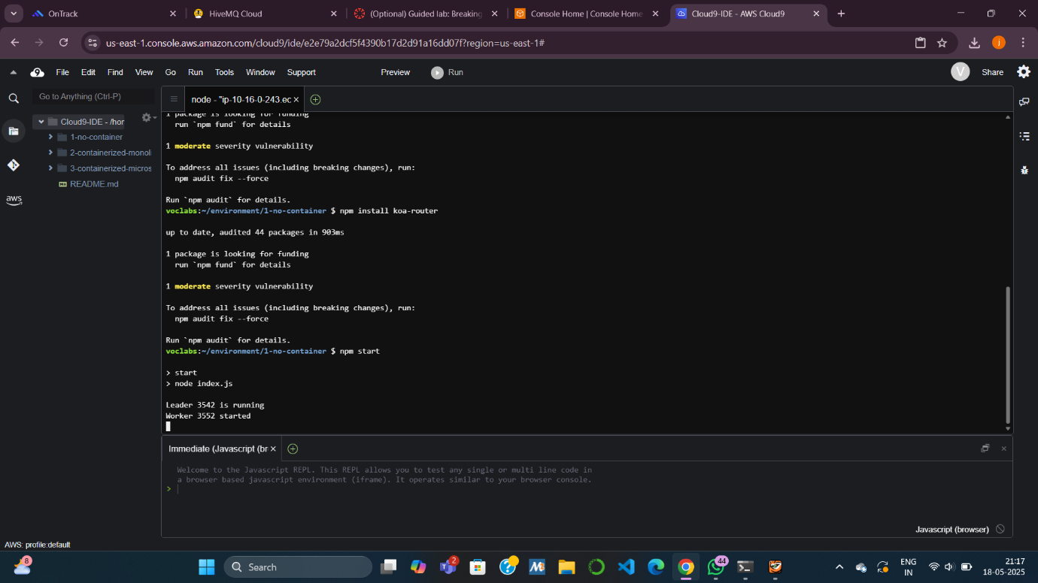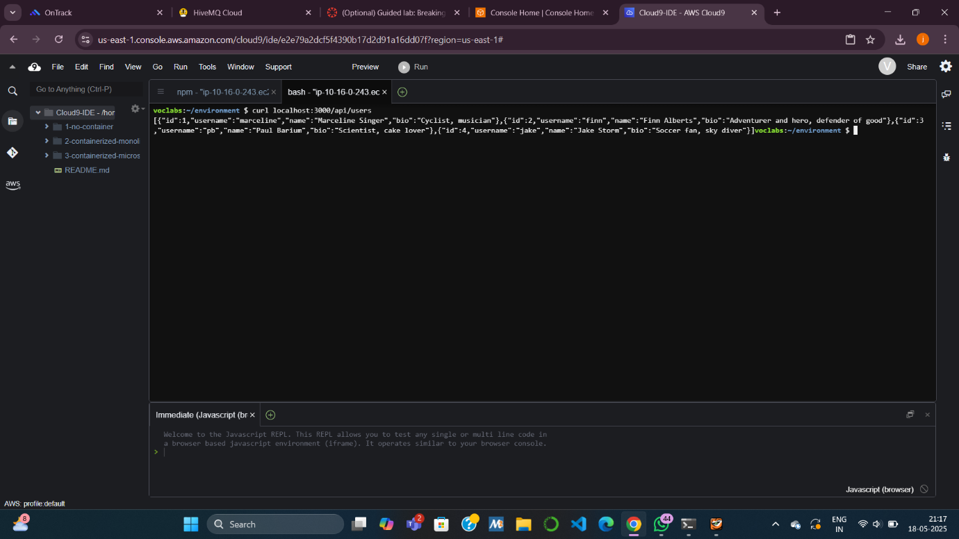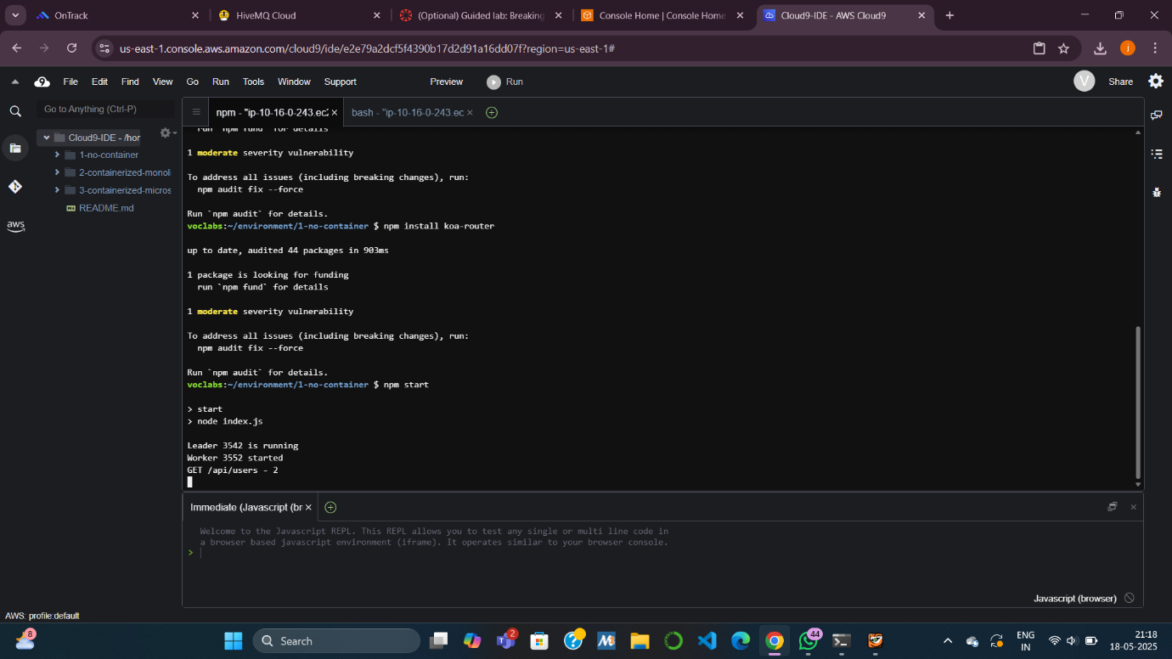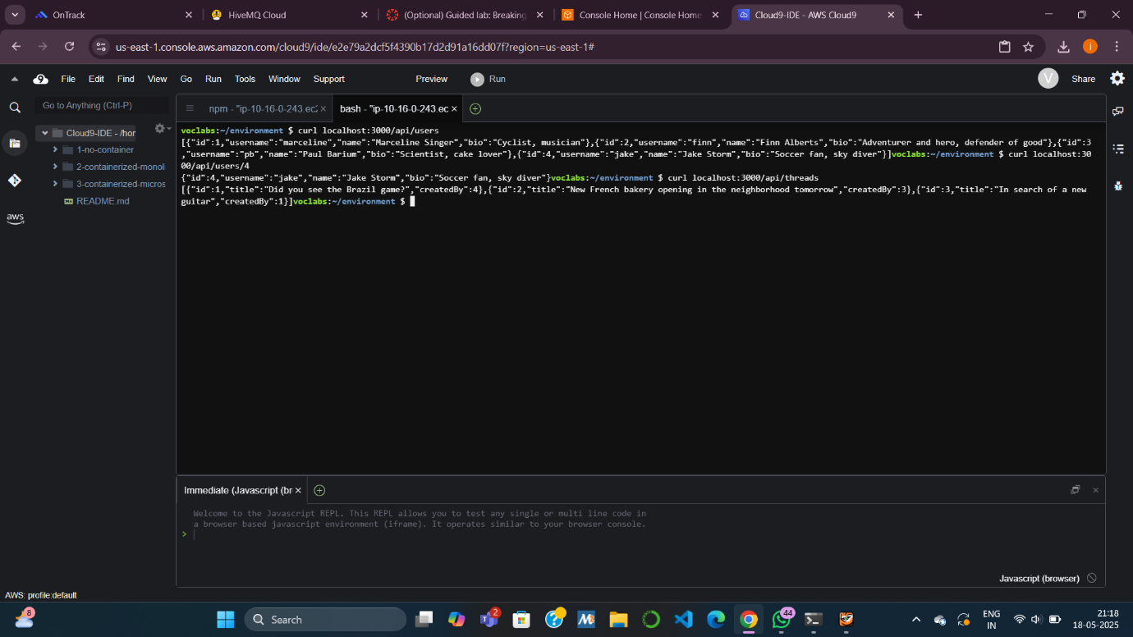

**Task 3: Containerizing the Monolith for Amazon ECS**

**Objective**: Prepare and push the **monolithic app** to Docker and ECR.

**Subtasks:**

* **3.1 Modify the app**:
  + Remove cluster logic (no index.js).
  + Use server.js as the main app file.
  + Add a Dockerfile to define image instructions.
* **3.2 Create ECR Repository**:
  + Go to **Amazon ECR** → Create **mb-repo** (private).
* **3.3 Build & Push Docker Image**:
  + Authenticate Docker to AWS.
  + Run docker build -t mb-repo .
  + Tag the image with repository URI.
  + Push to ECR with docker push.

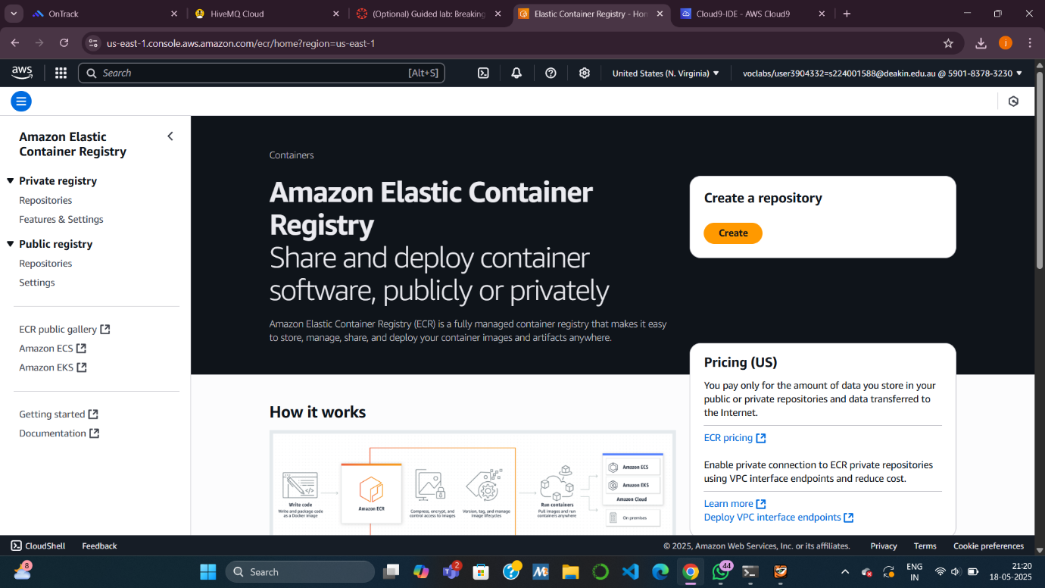

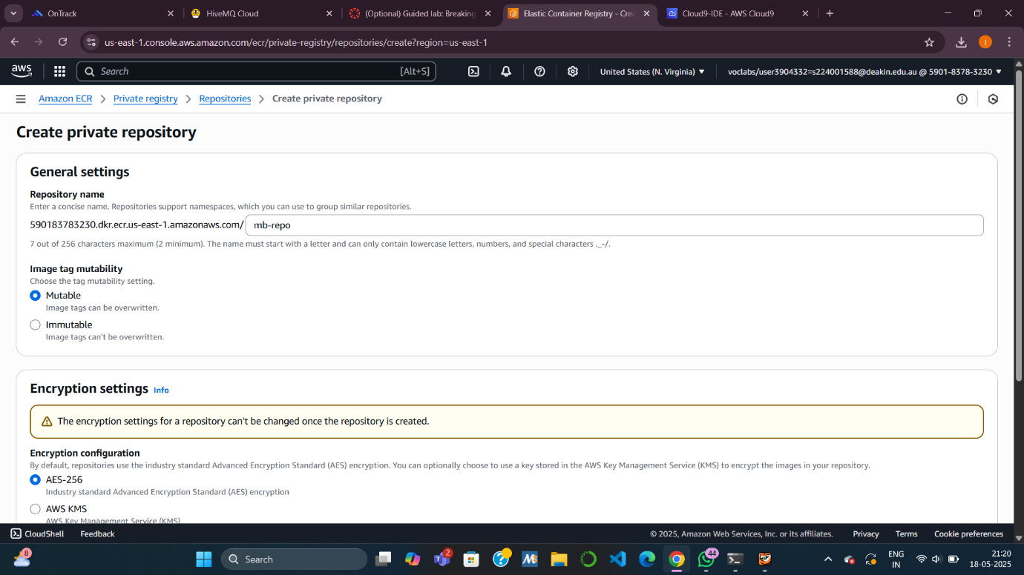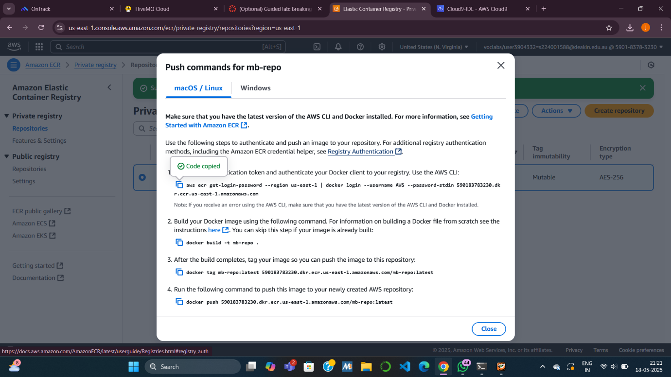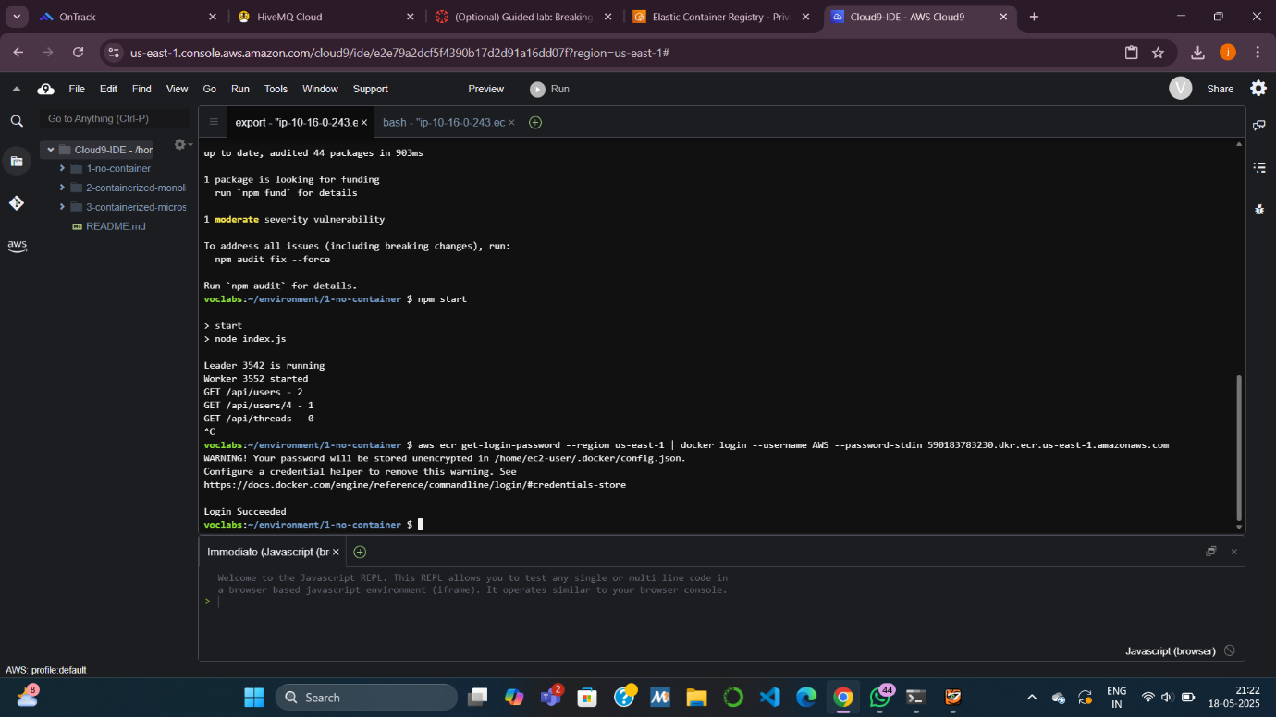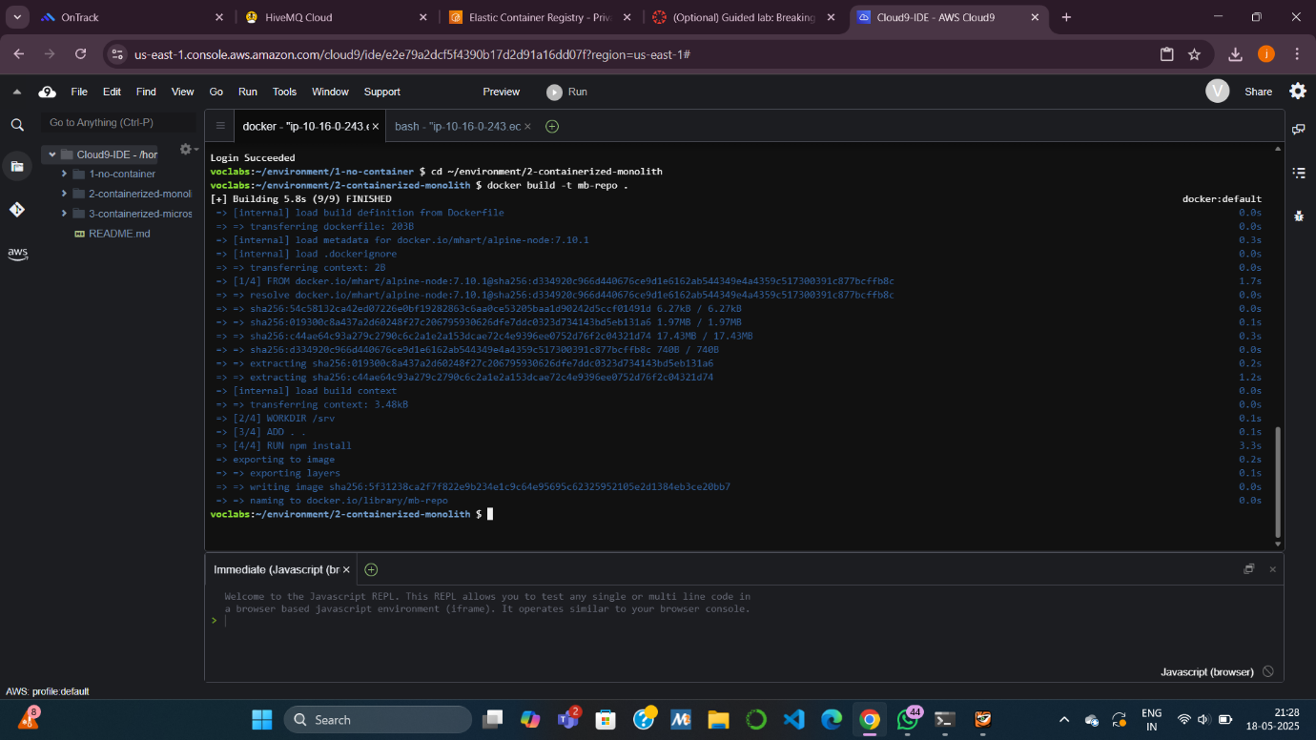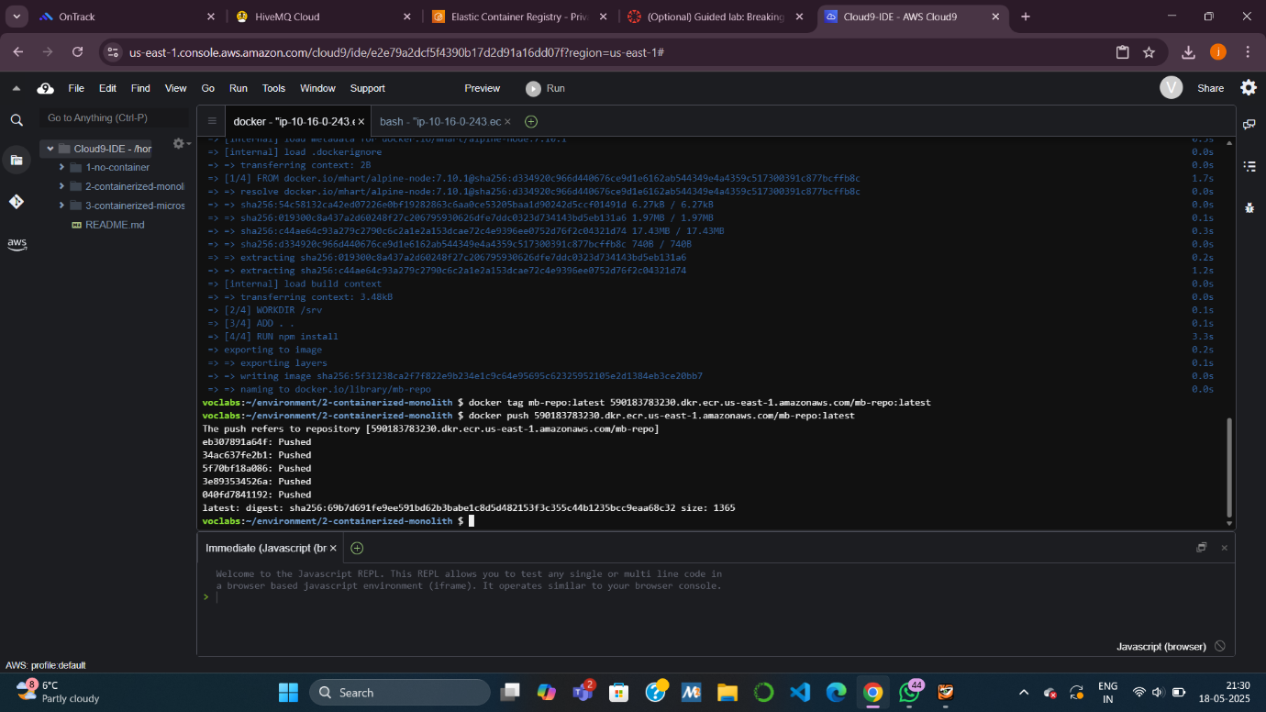

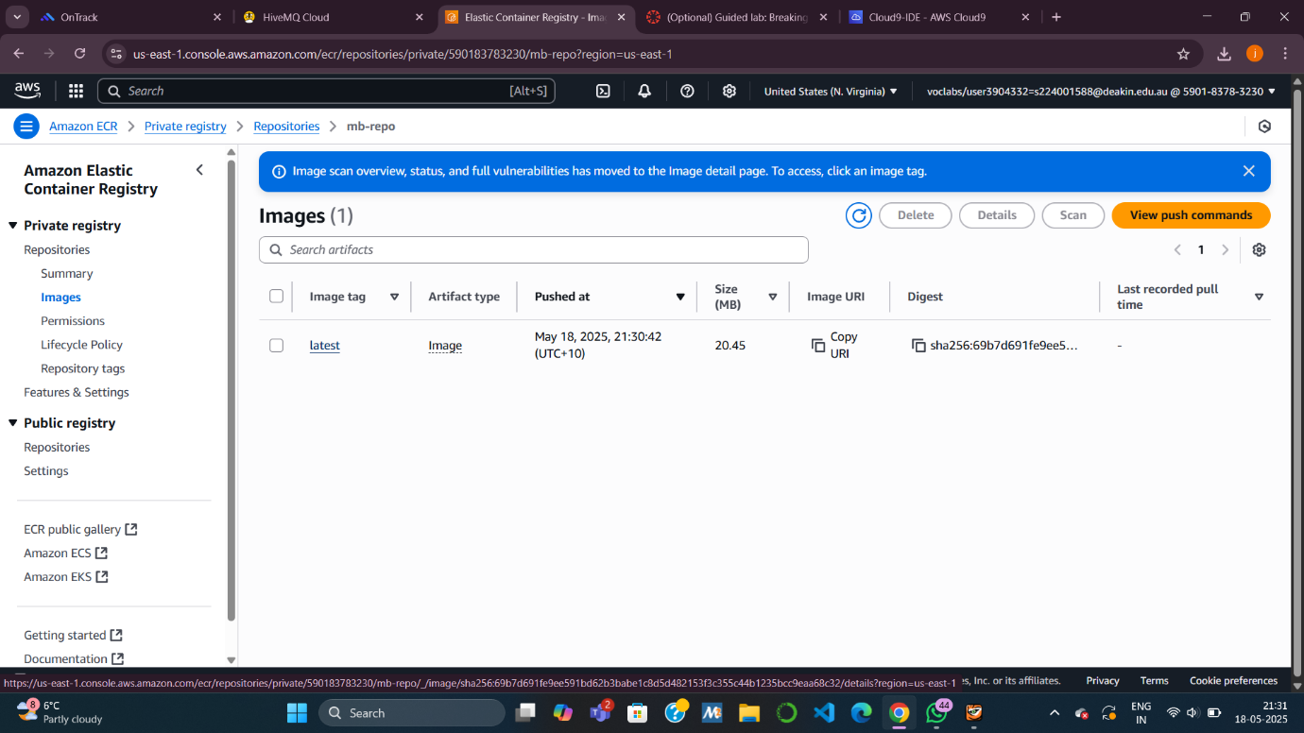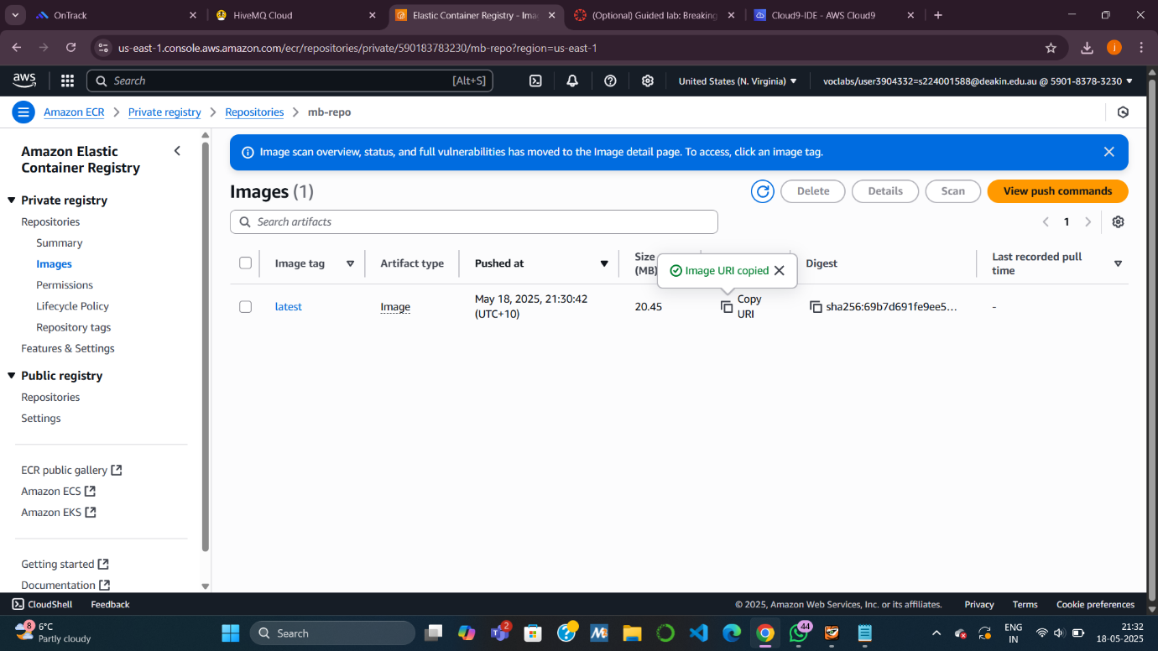

**Task 4: Deploying the Monolith to Amazon ECS**

**Objective**: Deploy the containerized monolith on ECS with EC2 and a Load Balancer.

**Subtasks:**

* **4.1 Create ECS Cluster**:
  + Use **EC2 launch type**, 2 instances, t2.medium, public subnets.
* **4.2 Create Task Definition**:
  + Name: mb-task.
  + Container: mb-container, image from ECR, port 3000.
* **4.3 Deploy as ECS Service**:
  + Create service: mb-ecs-service.
  + Attach it to a **new Application Load Balancer (ALB)**.
* **4.4 Test API**:
  + Use Load Balancer DNS to test endpoints like:
    - /api
    - /api/users
    - /api/posts/in-thread/2

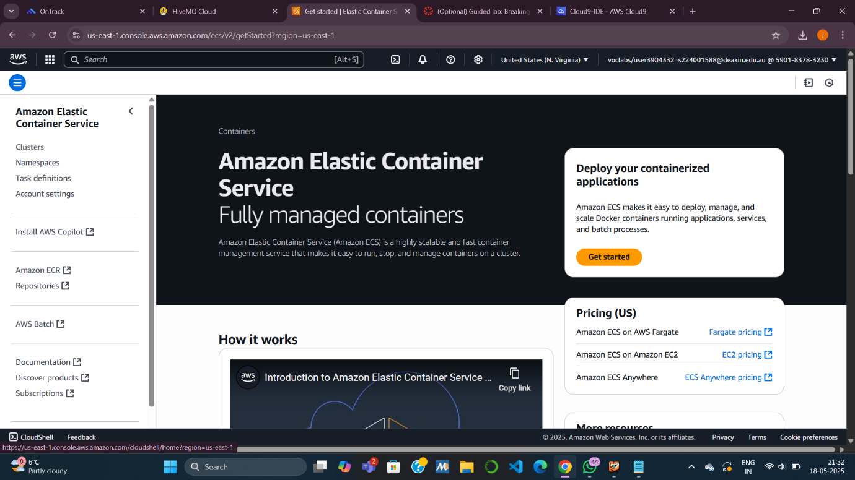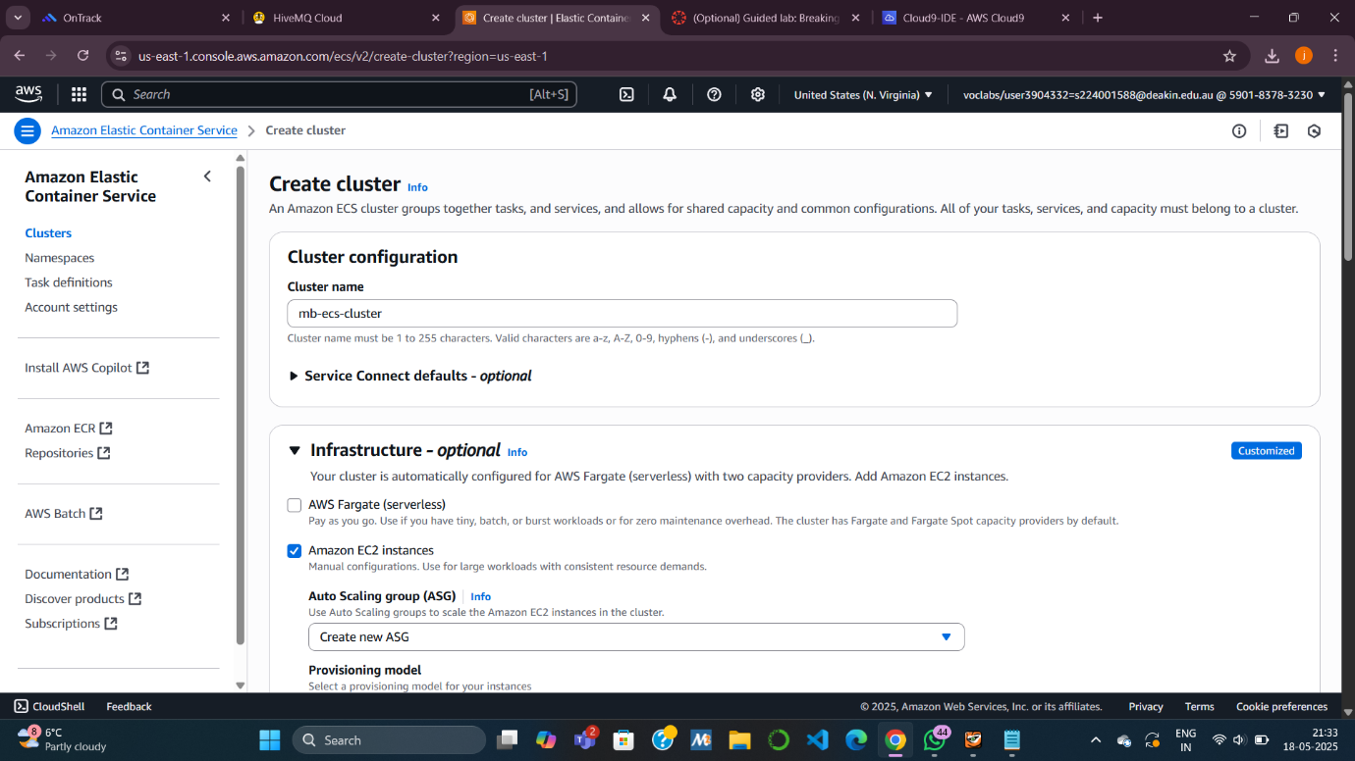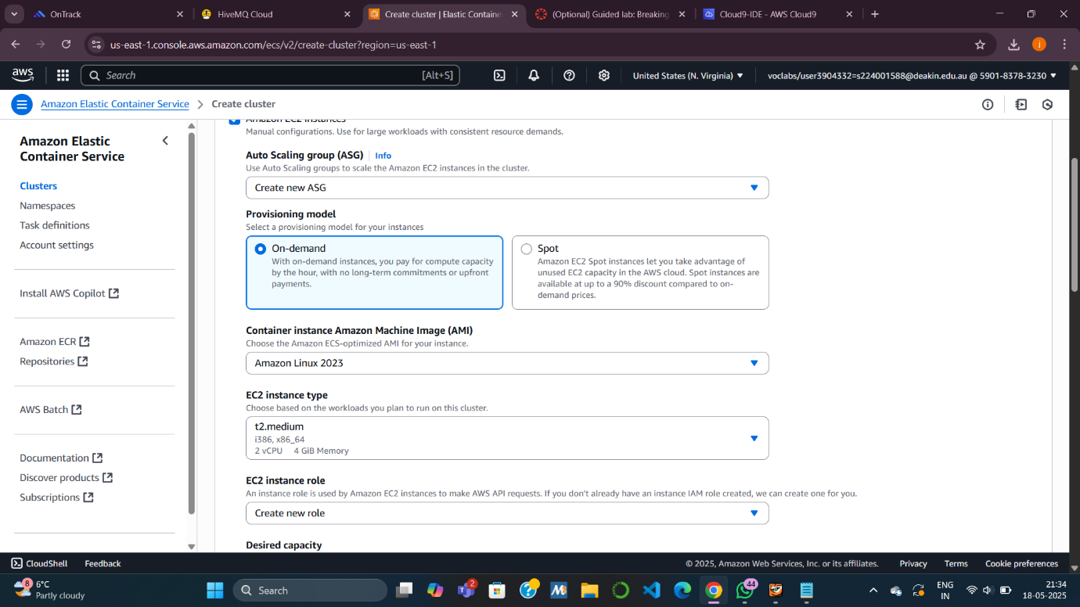

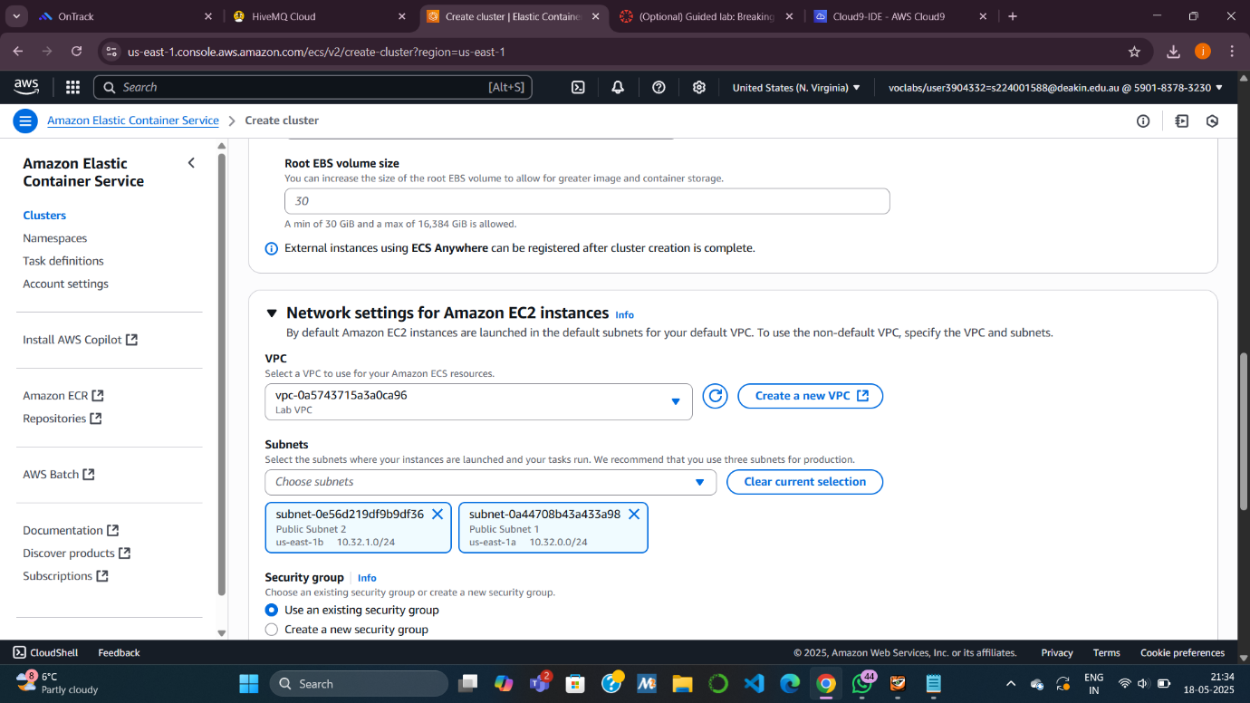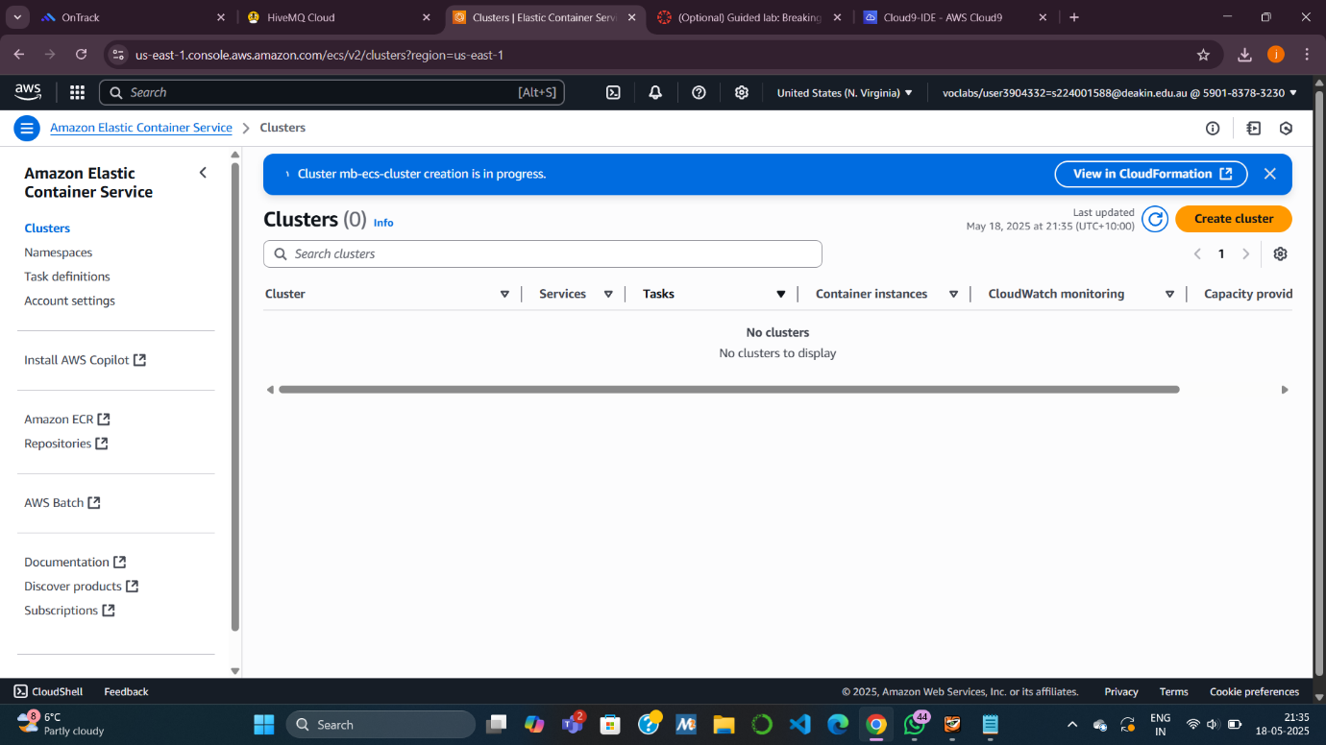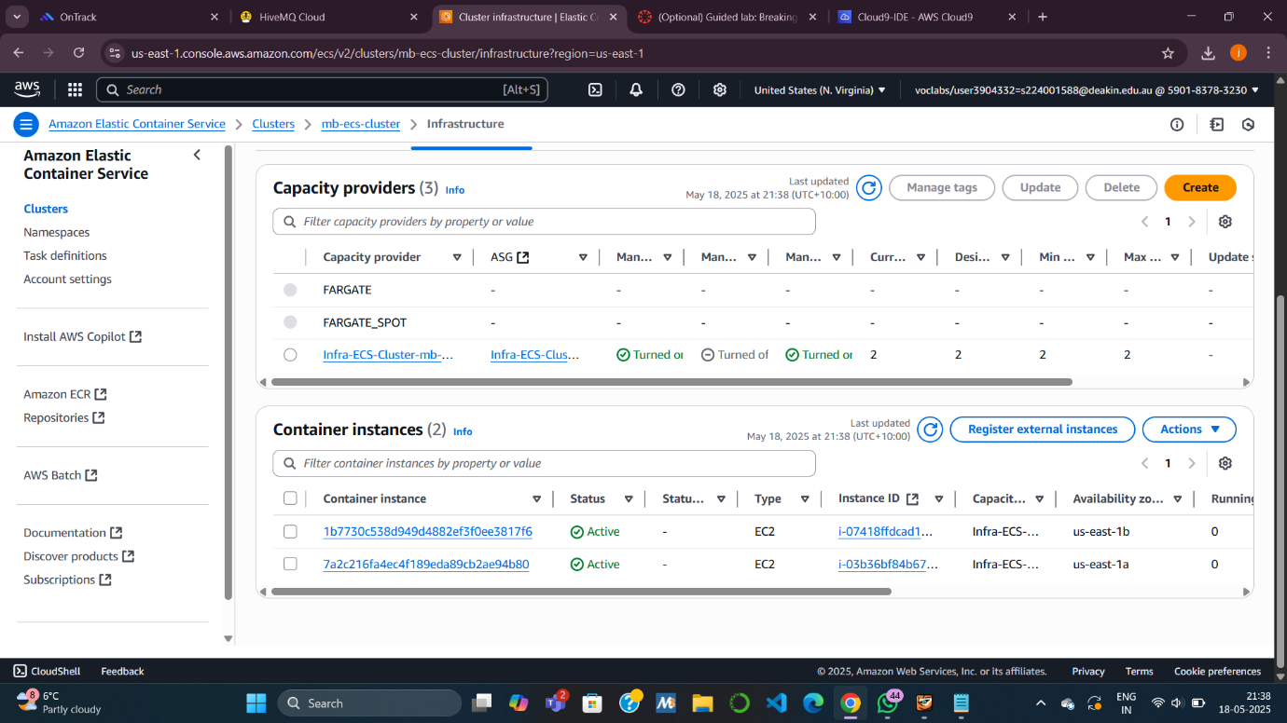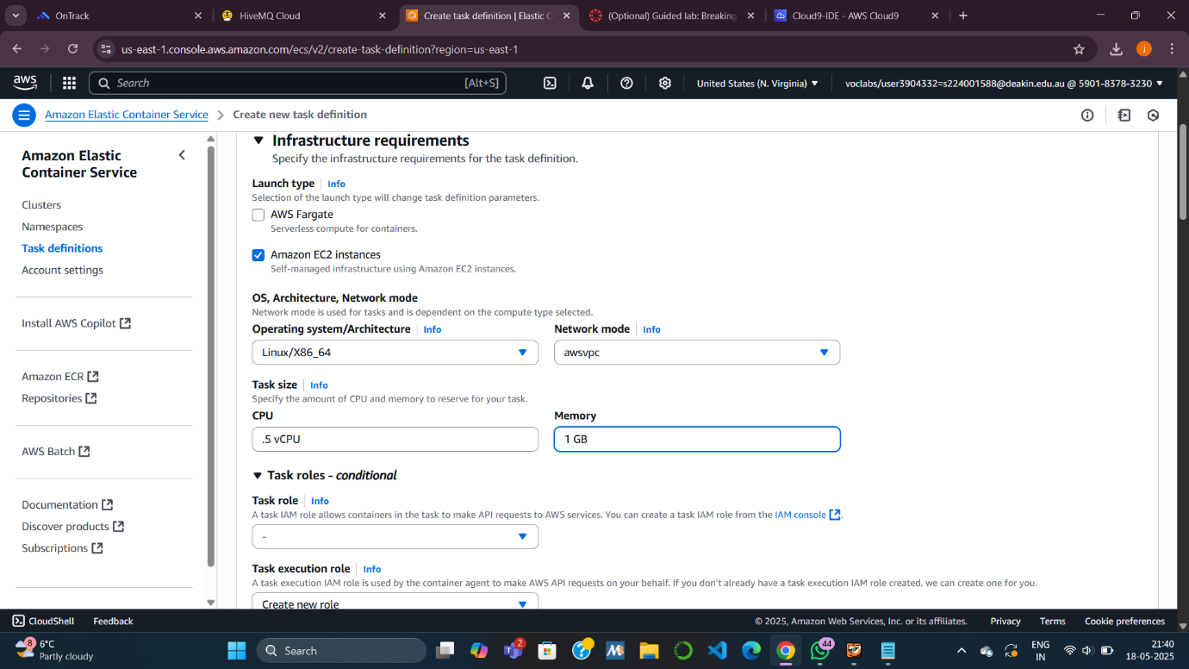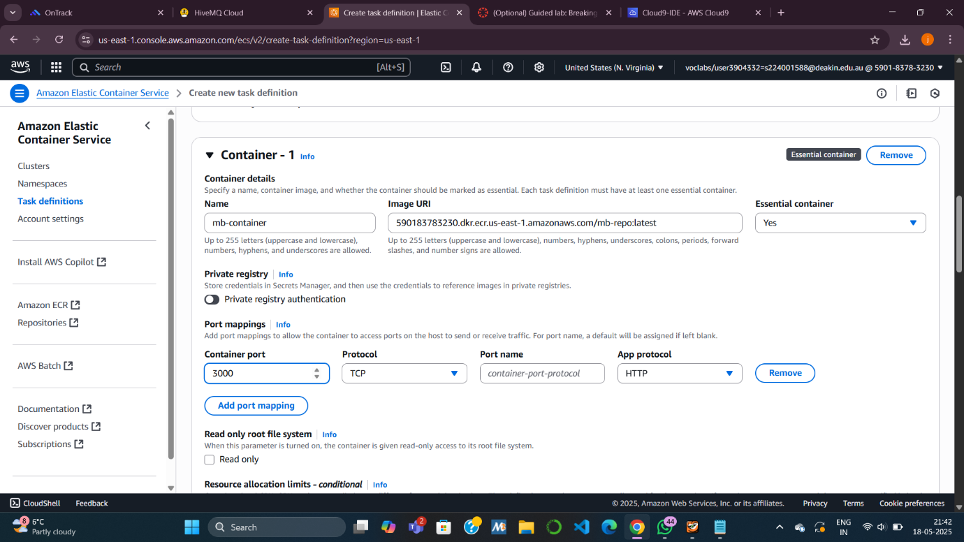

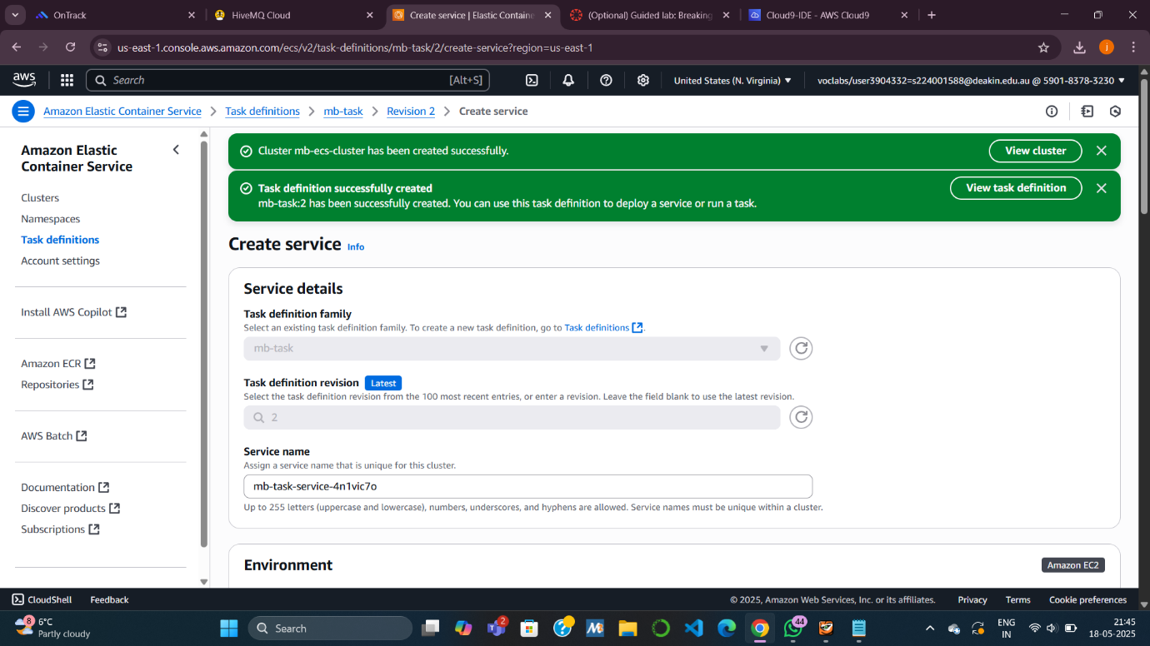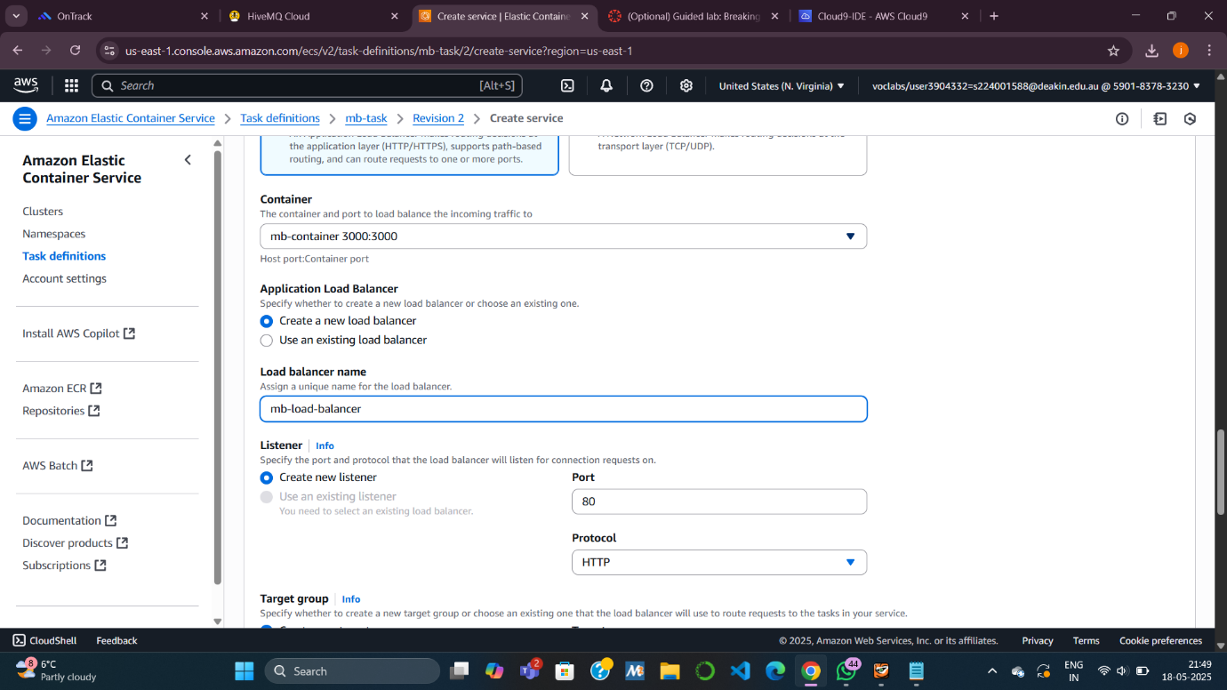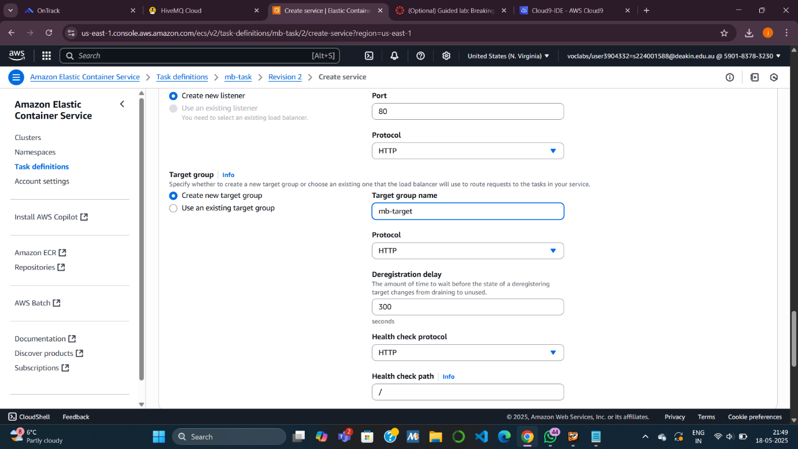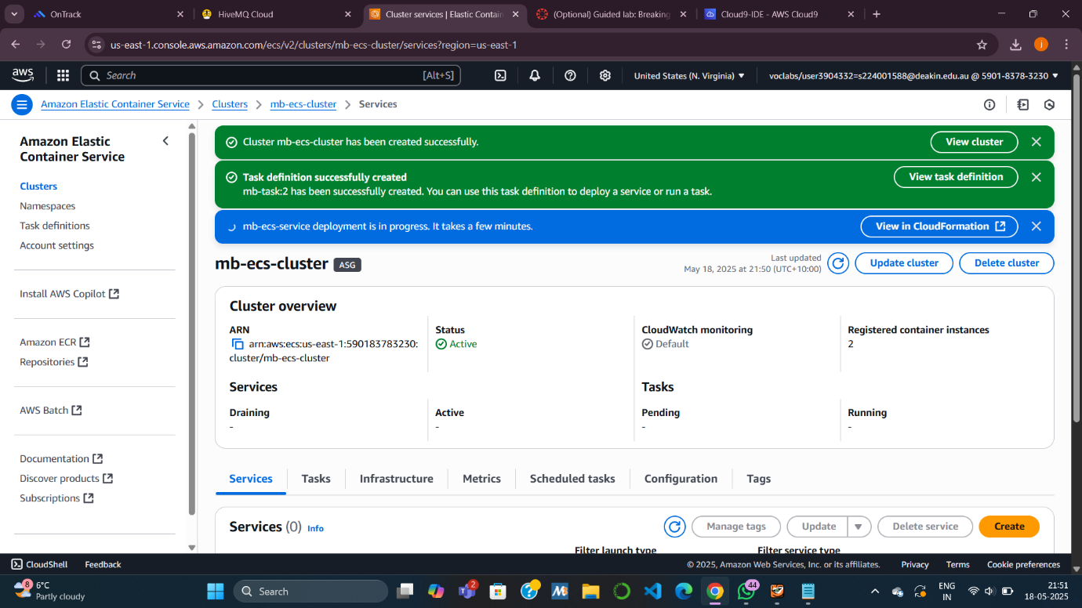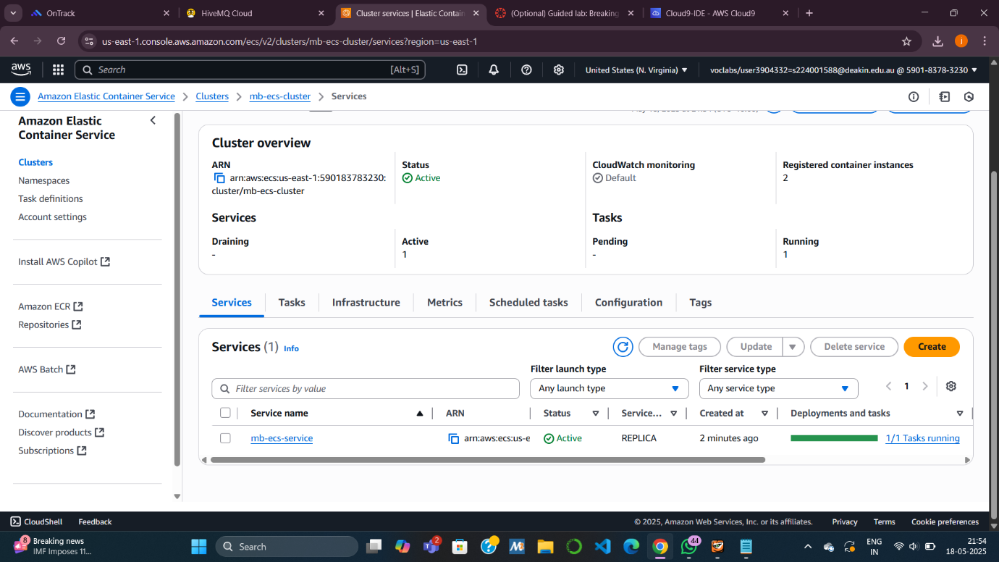

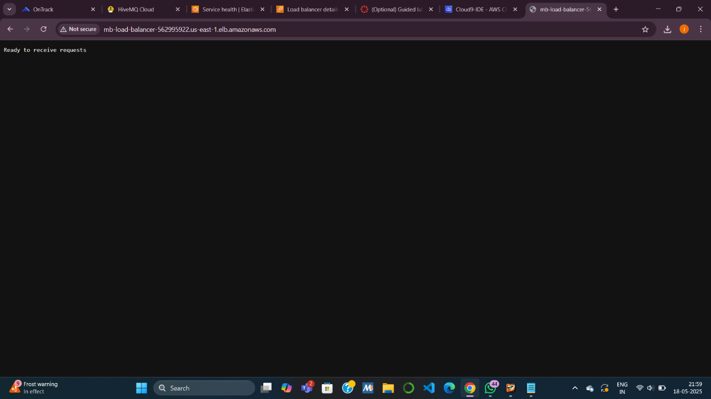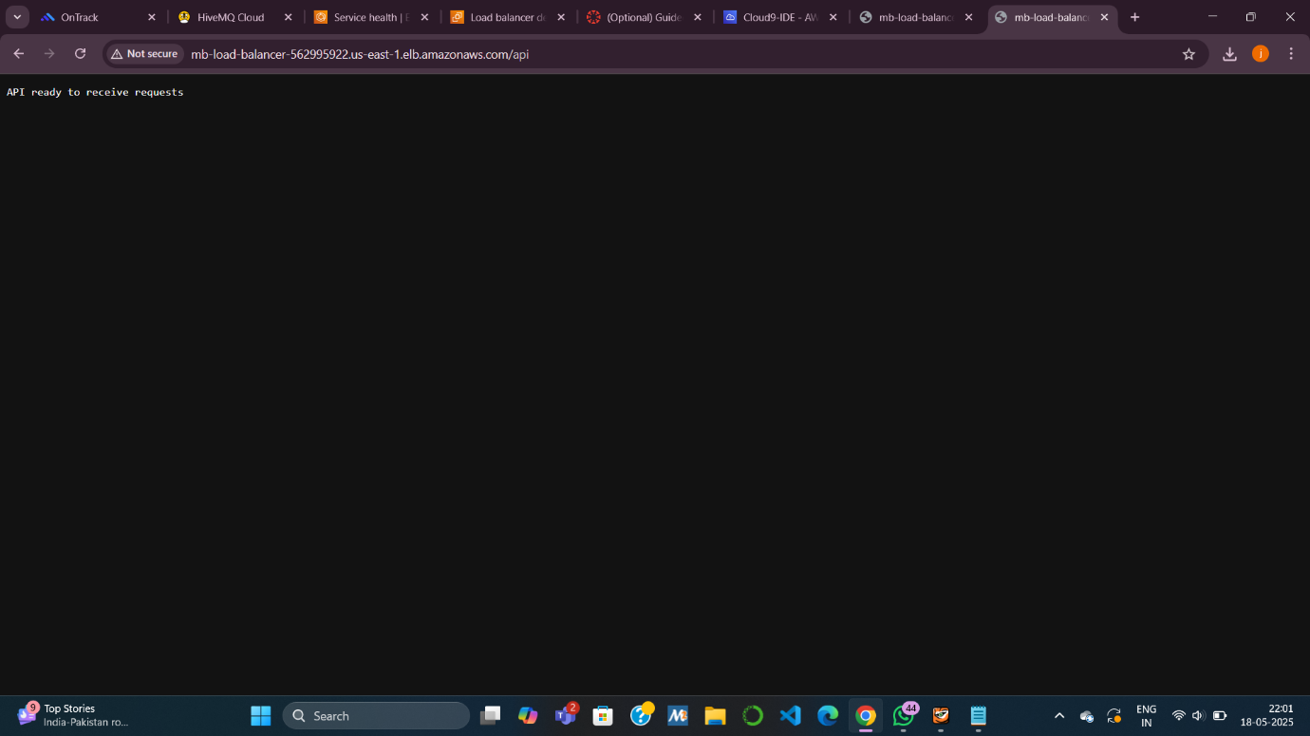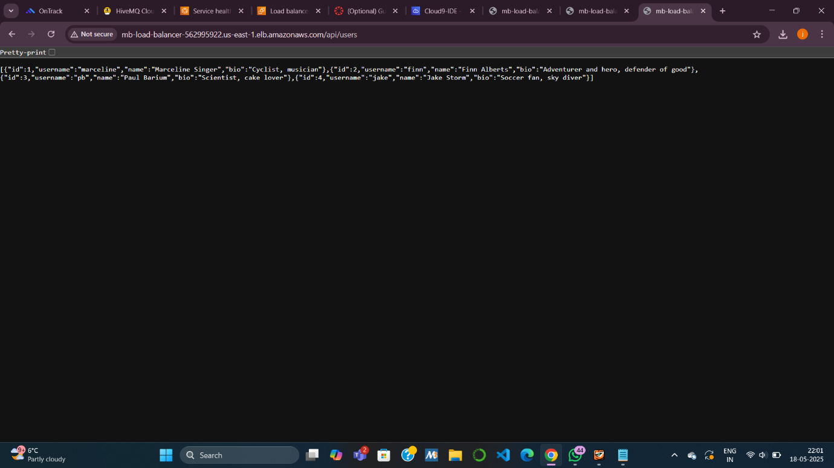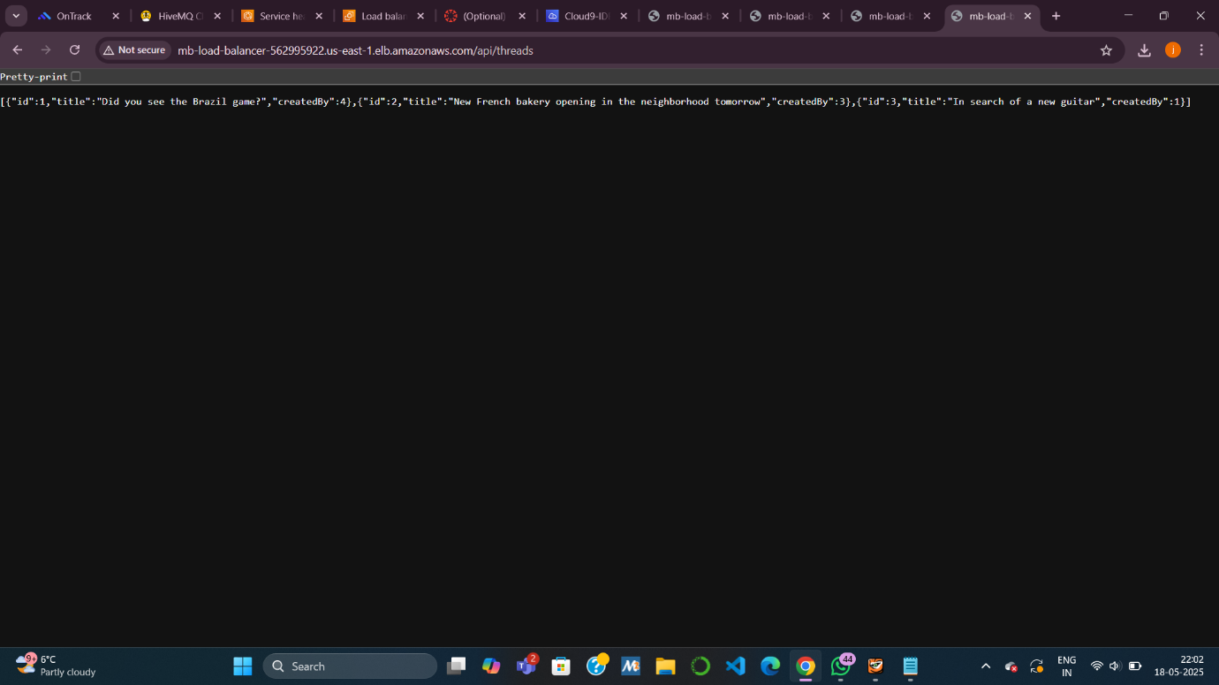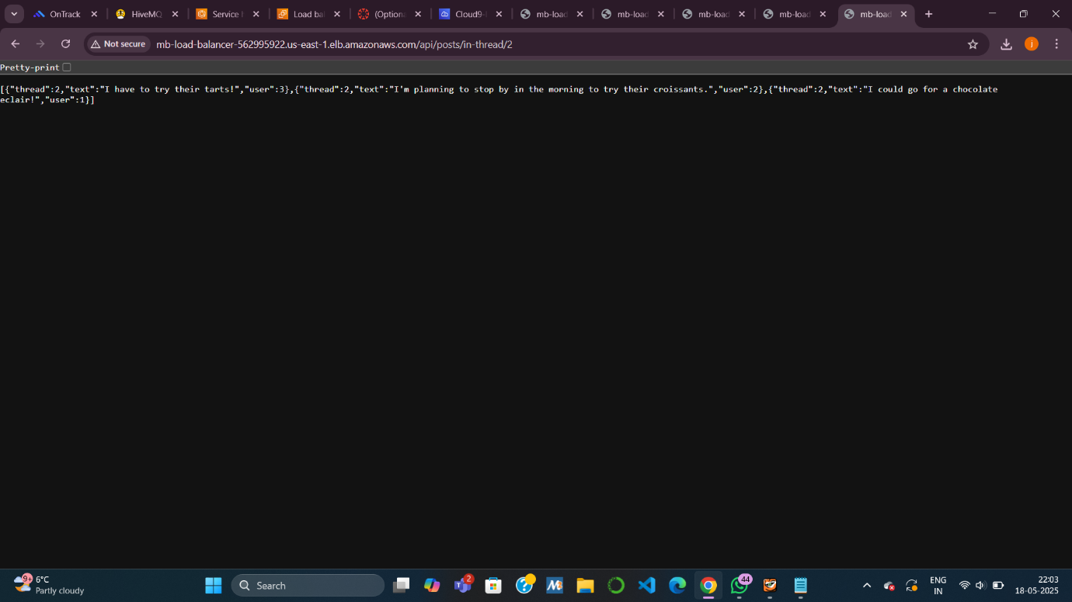

**Task 5: Refactoring the Monolith**

**Objective**: Break the monolith into **3 separate microservices**.

**Subtasks:**

* **5.1 Review Refactored App**:
  + Each microservice has its own folder: users, threads, posts.
  + server.js in each folder contains only relevant endpoints.
* **5.2 Create Repositories**:
  + ECR repos: mb-users-repo, mb-threads-repo, mb-posts-repo.
* **5.3 Build & Push Images**:
  + For each service:
    - cd into folder.
    - Run build → tag → push using ECR-provided commands.
    - Verify upload and save image URIs.
* 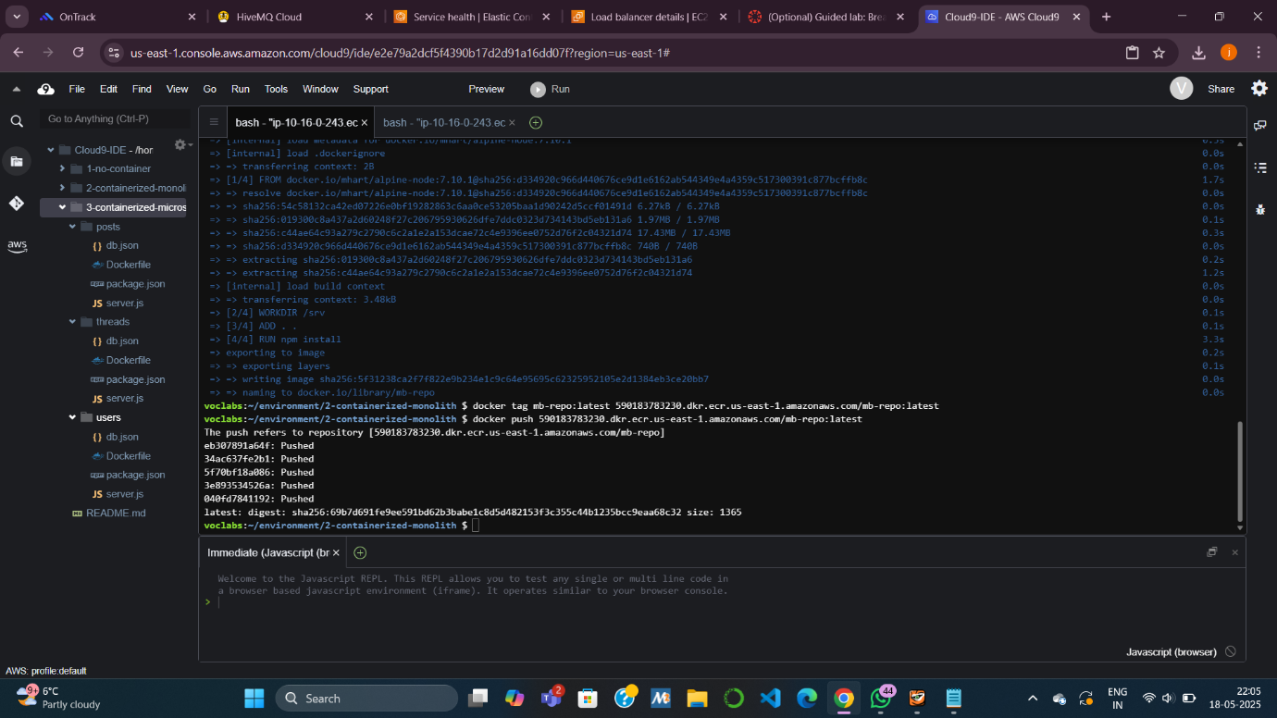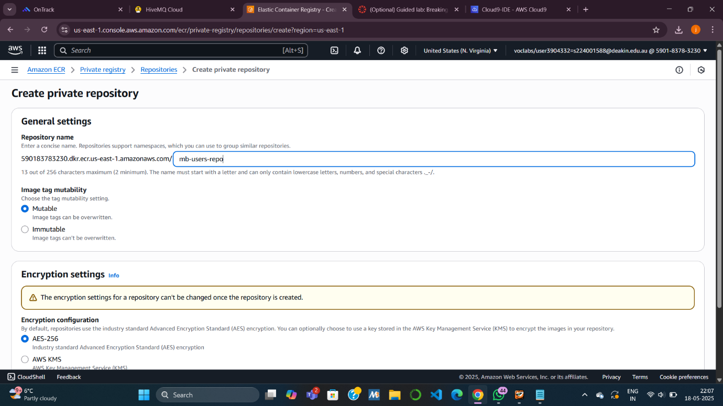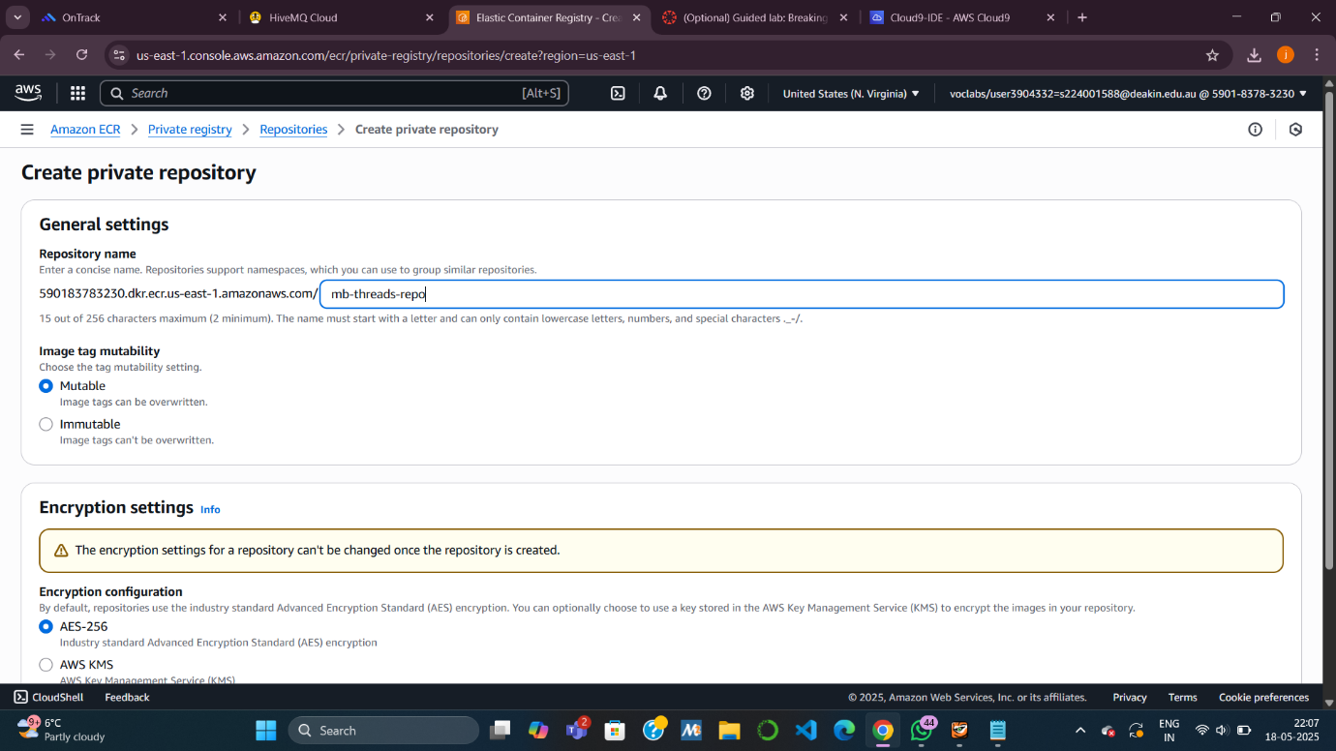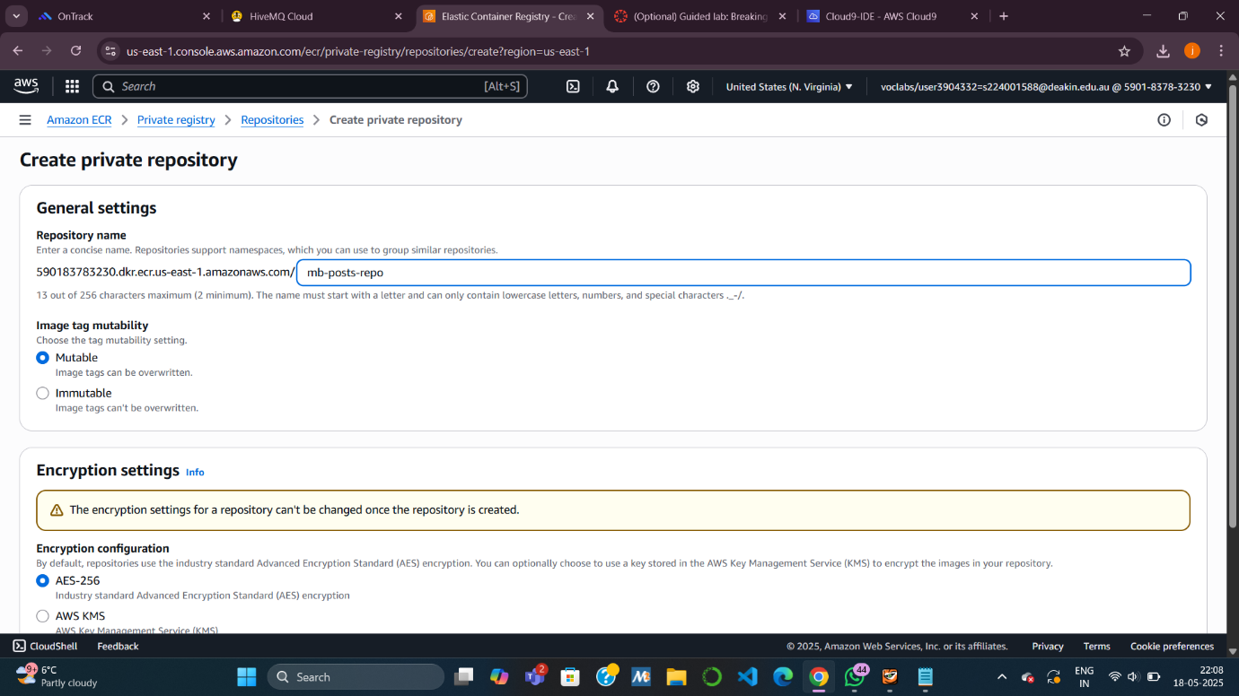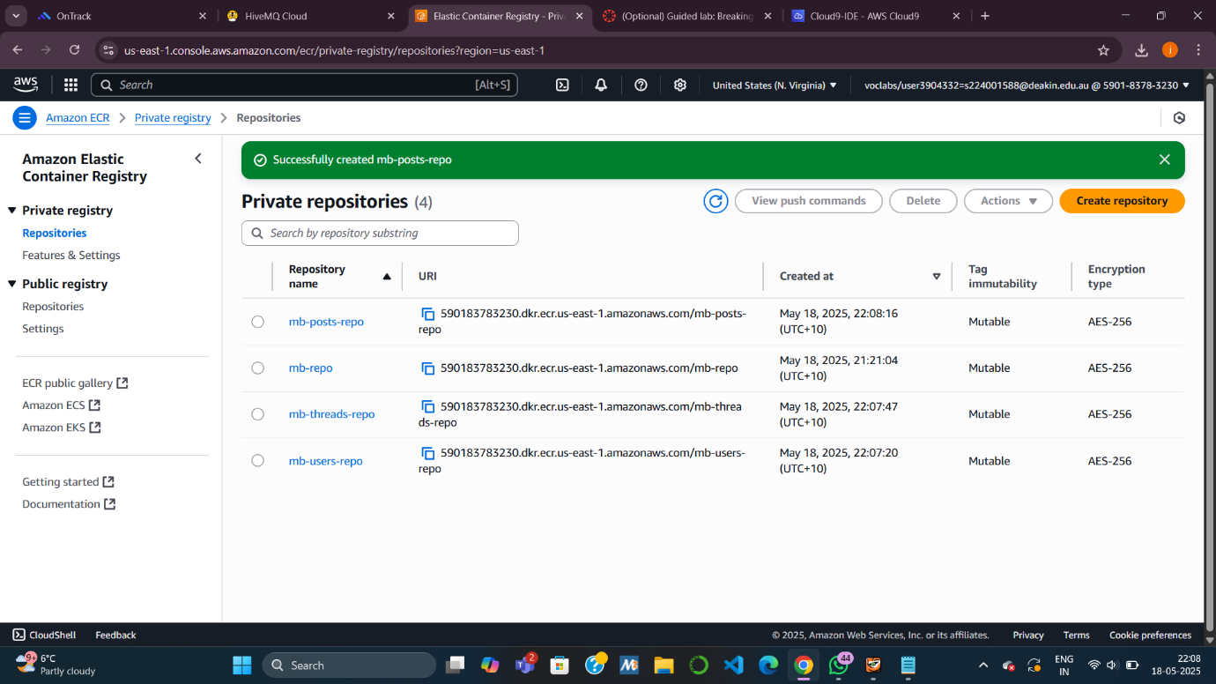

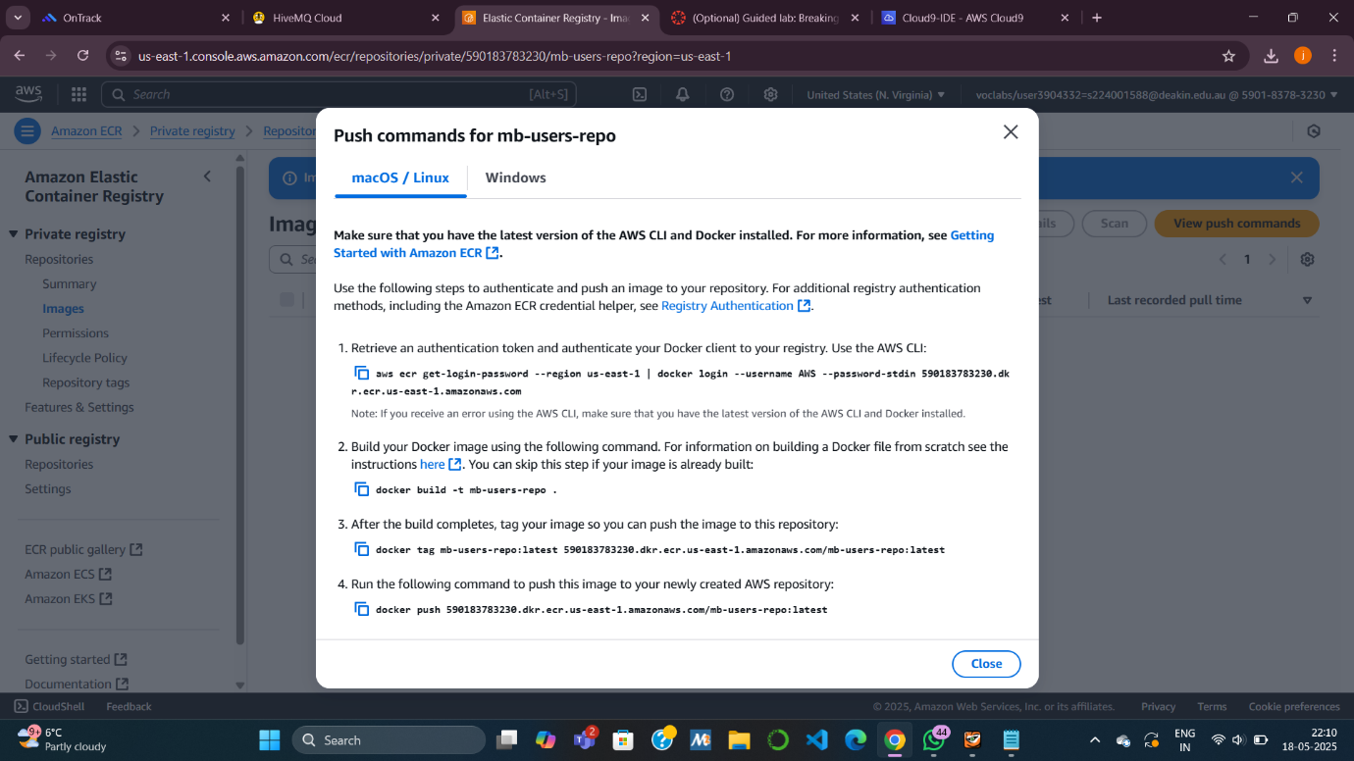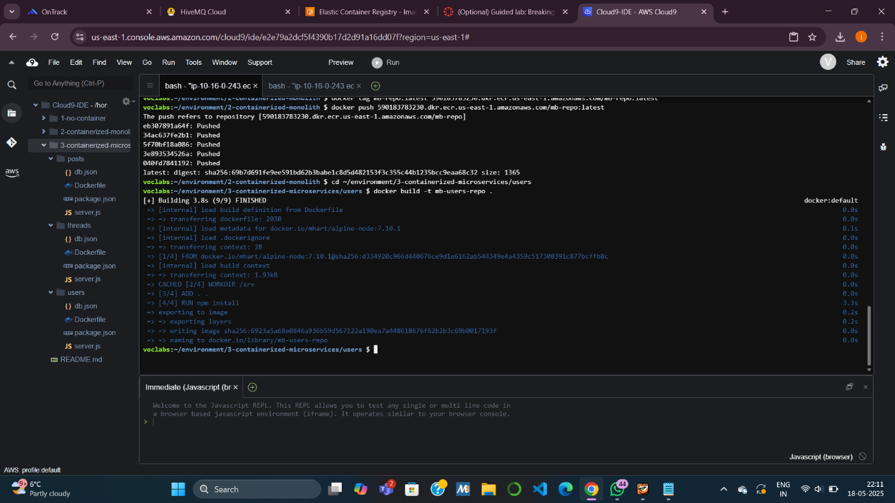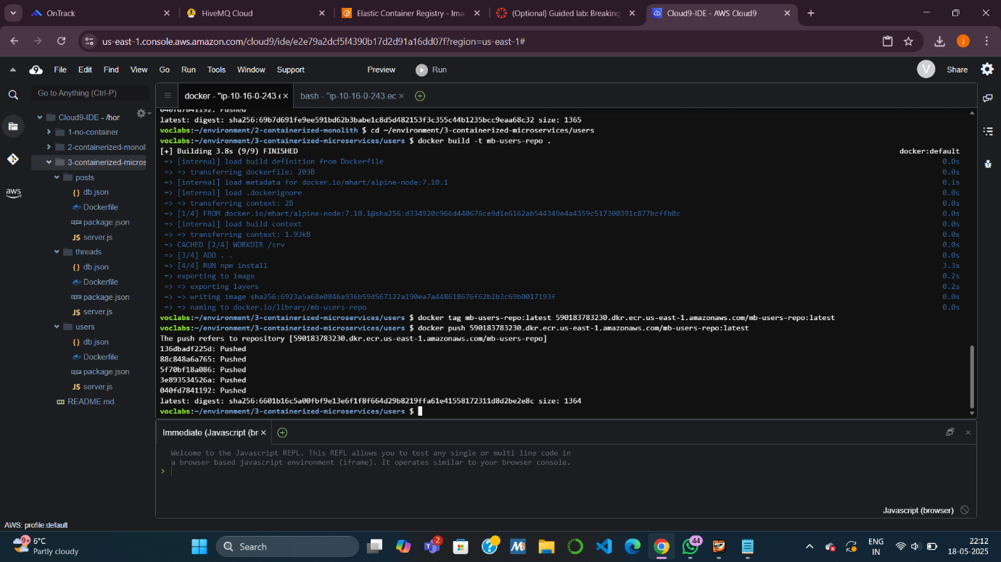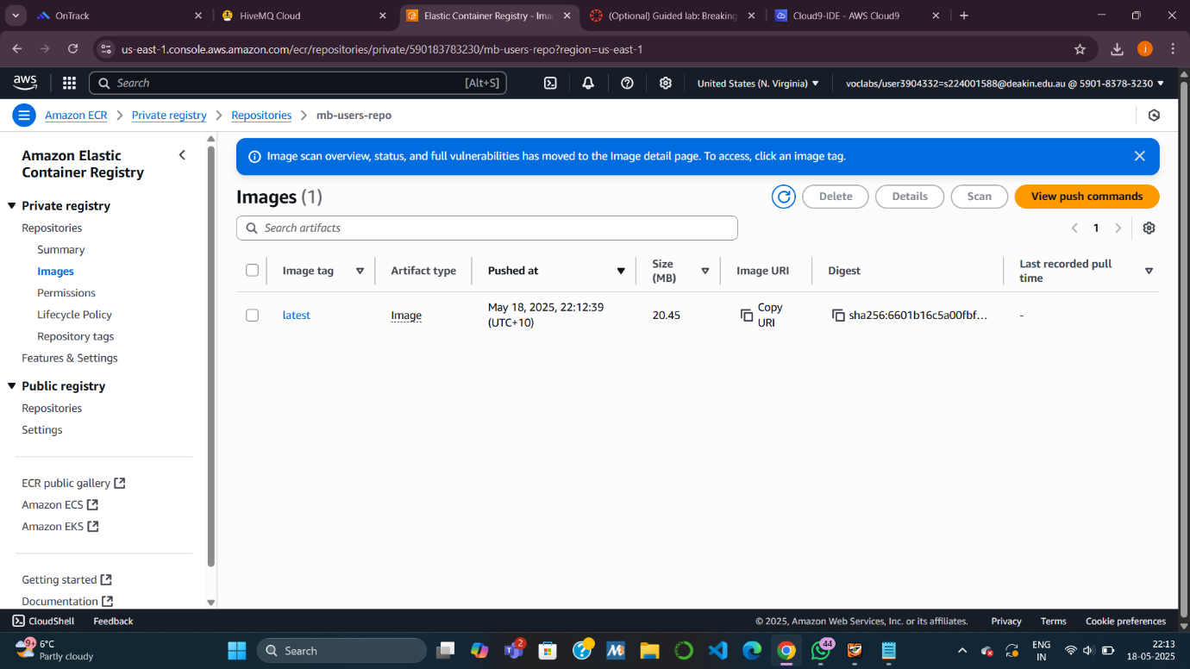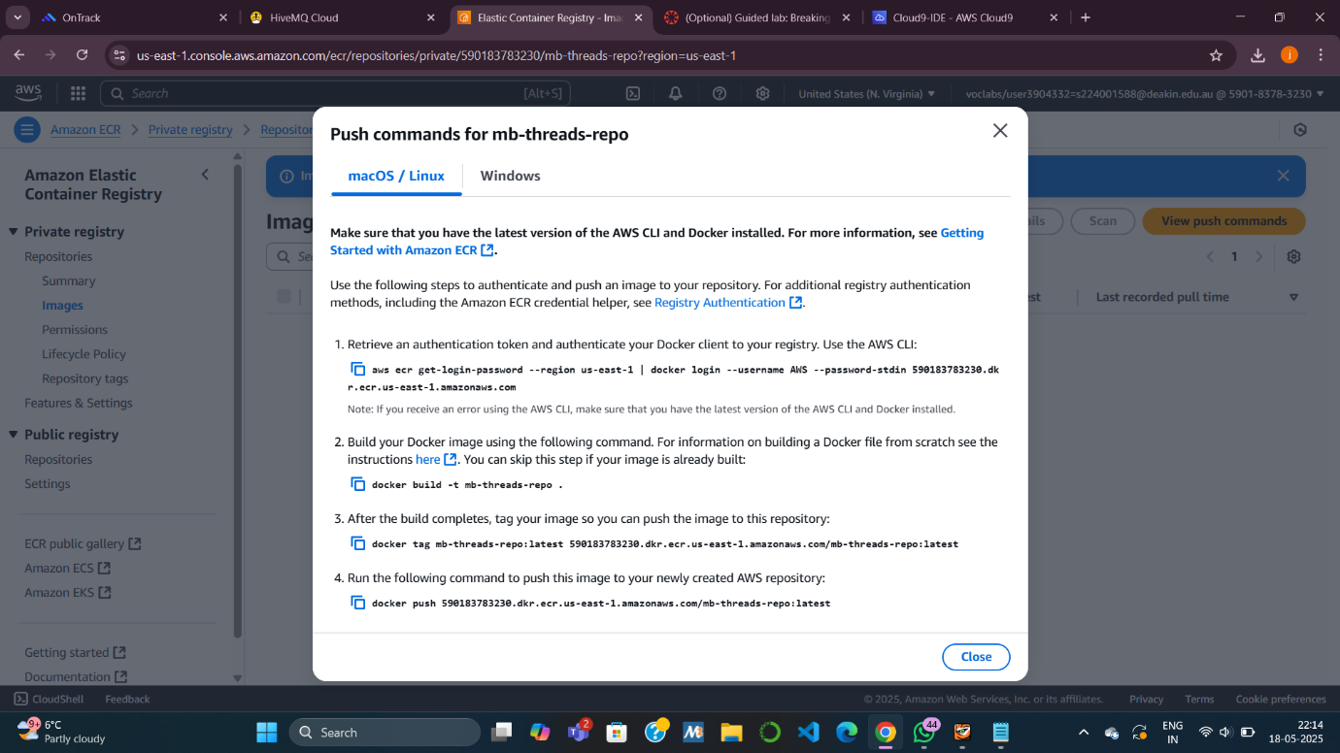

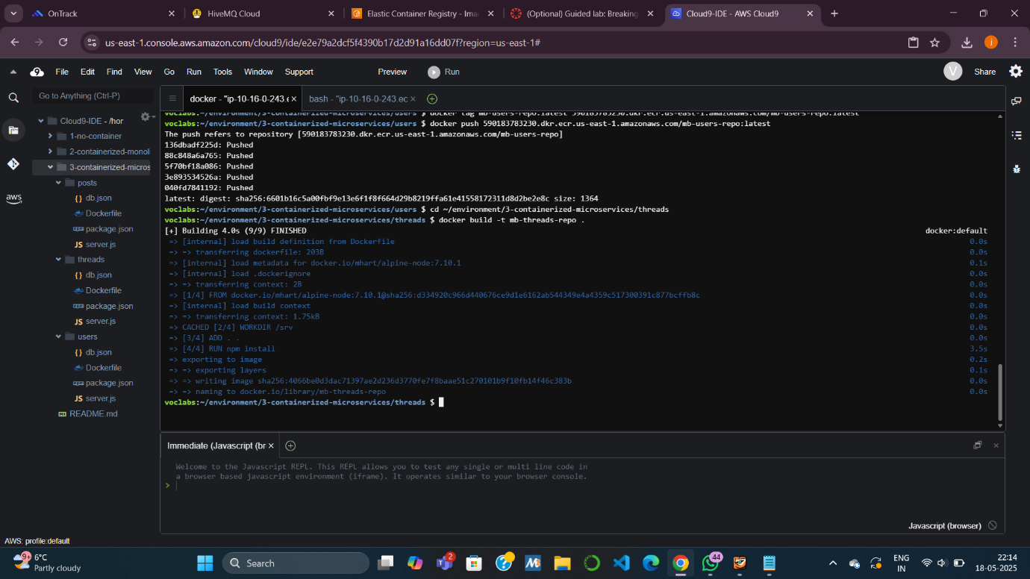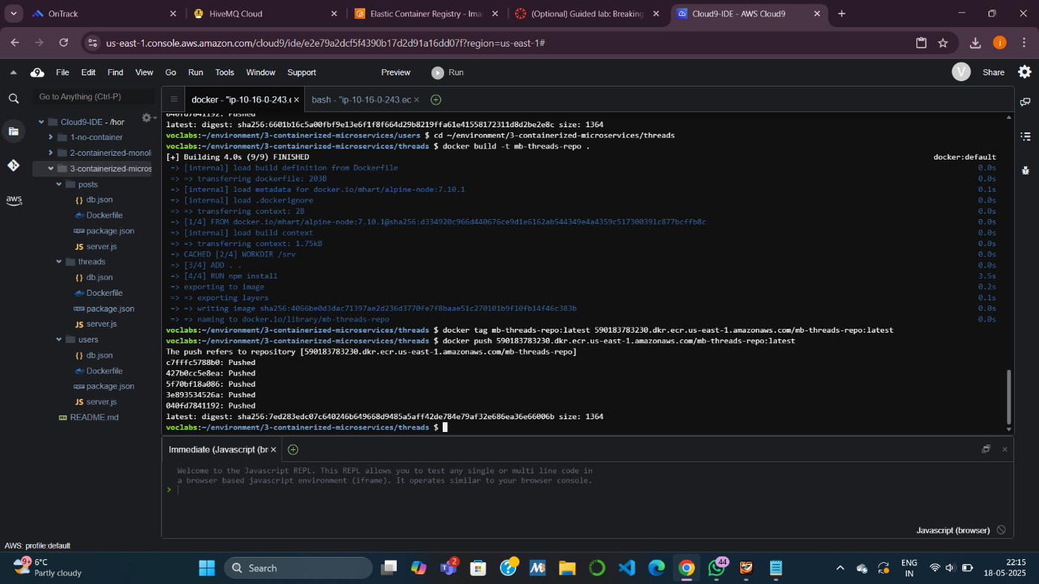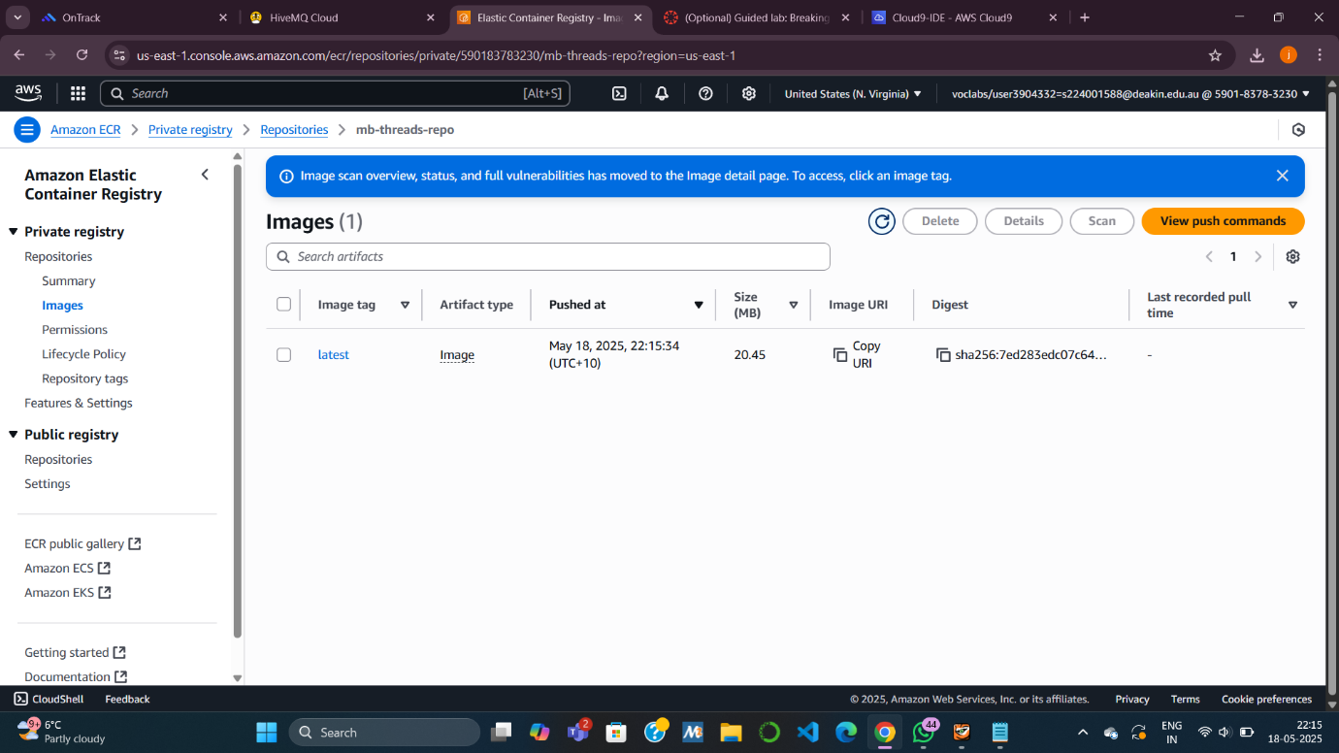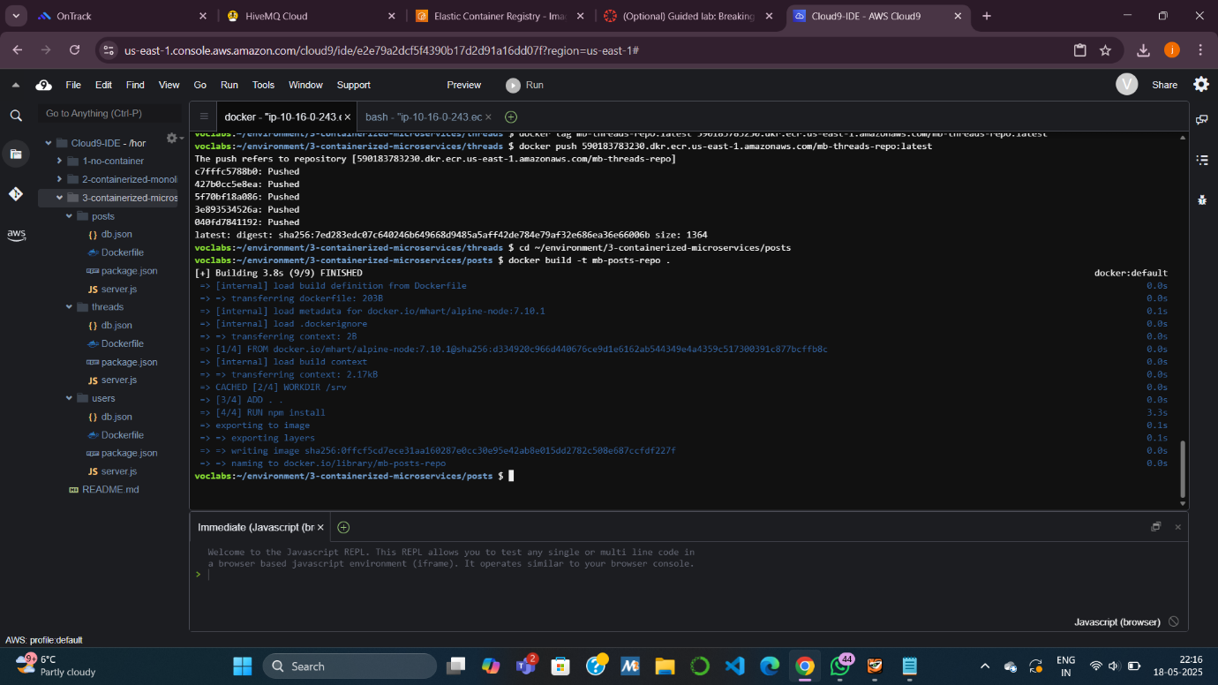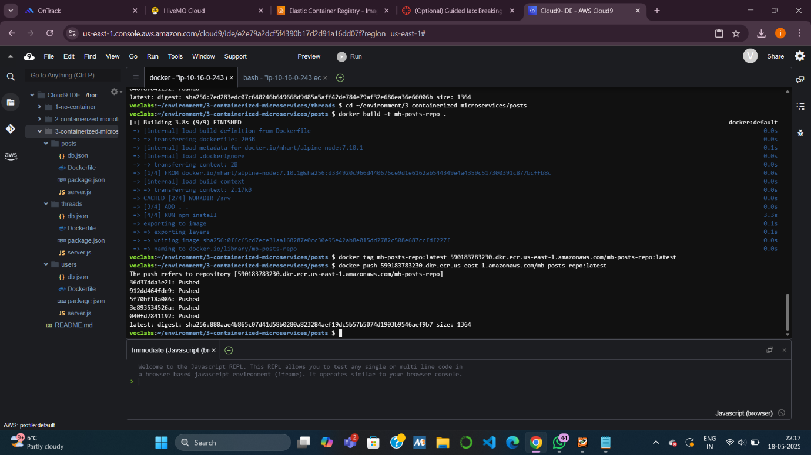

**Task 6: Deploying the Containerized Microservices**

**Objective**: Deploy all 3 microservices to ECS, each routed by ALB using path patterns.

**Subtasks:**

* **6.1 Create Task Definitions**:
  + Create one task definition for each service:
    - mb-users-task, mb-threads-task, mb-posts-task.
* **6.2 Deploy Services**:
  + For each service:
    - Launch with EC2.
    - Connect to **existing Load Balancer (mb-load-balancer)**.
    - Define target group and path:
      * /api/users* → mb-users-target
      * /api/posts* → mb-posts-target
      * /api/threads* → mb-threads-target
  + Update ALB’s **default rule** to show "Invalid request" message.
  + Stop the **old monolithic service** (mb-ecs-service) by setting task count to 0.
* **6.3 Test Deployment**:
  + Test via Load Balancer DNS:
    - /api → users service
    - /api/users/2, /api/threads, /api/posts/in-thread/2
    - Invalid URL like /xxx returns error message
* 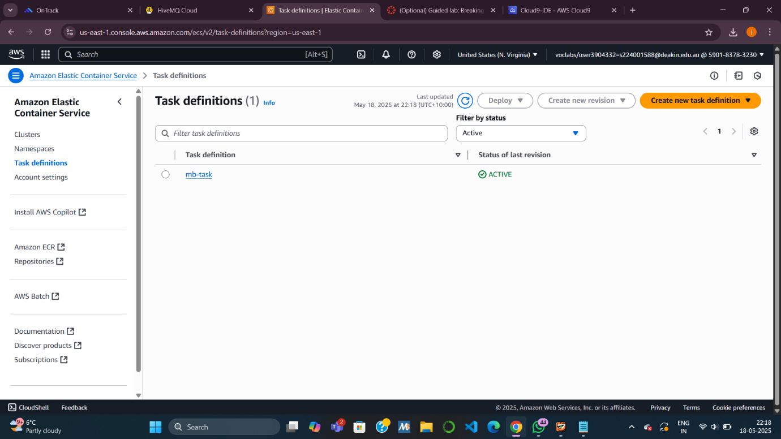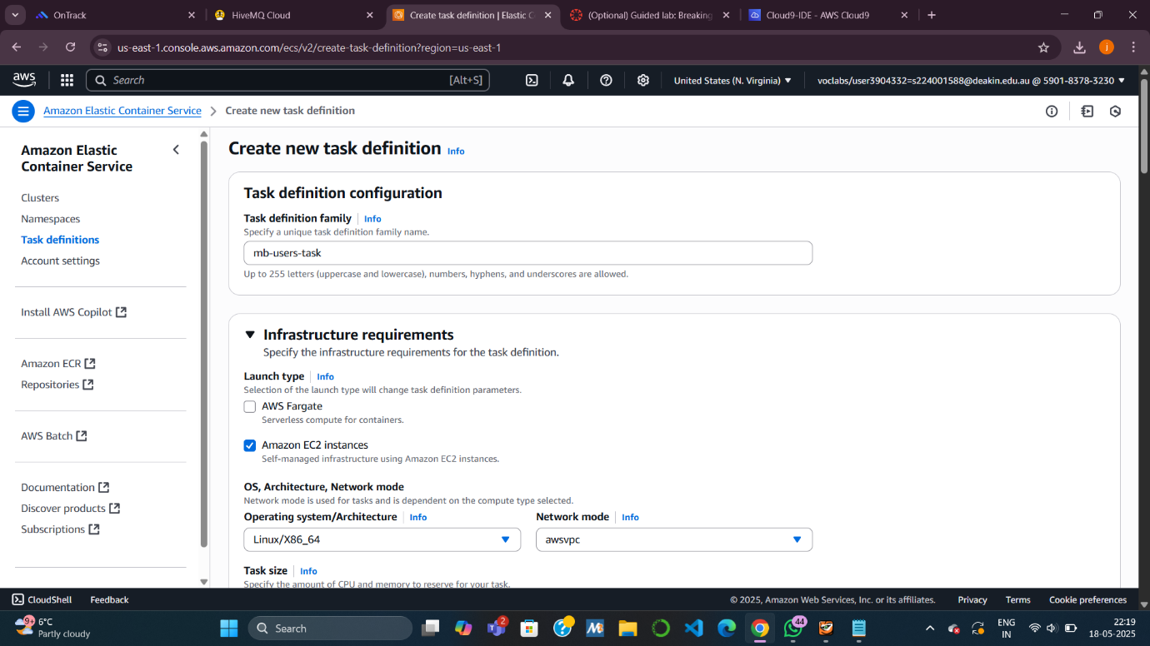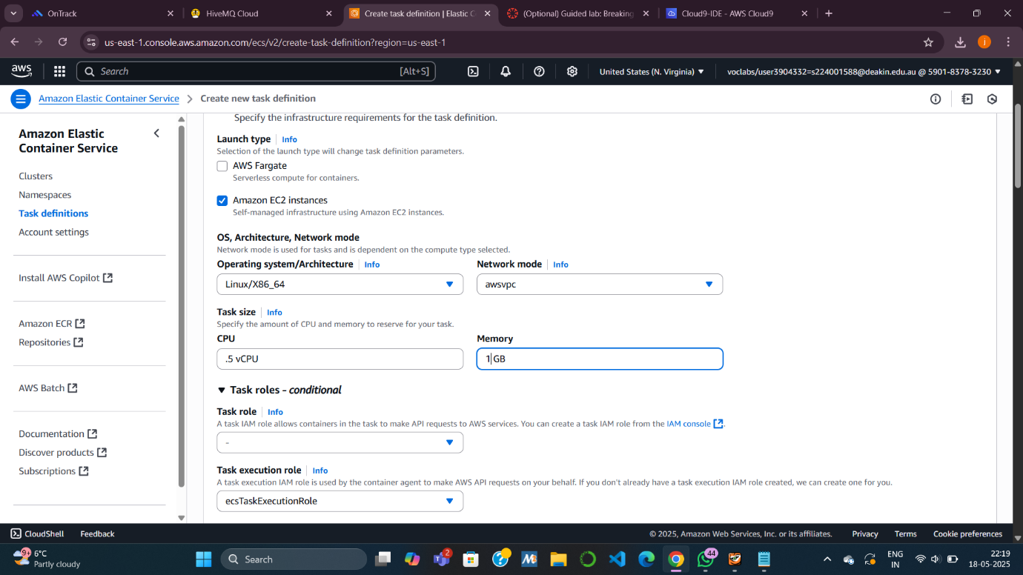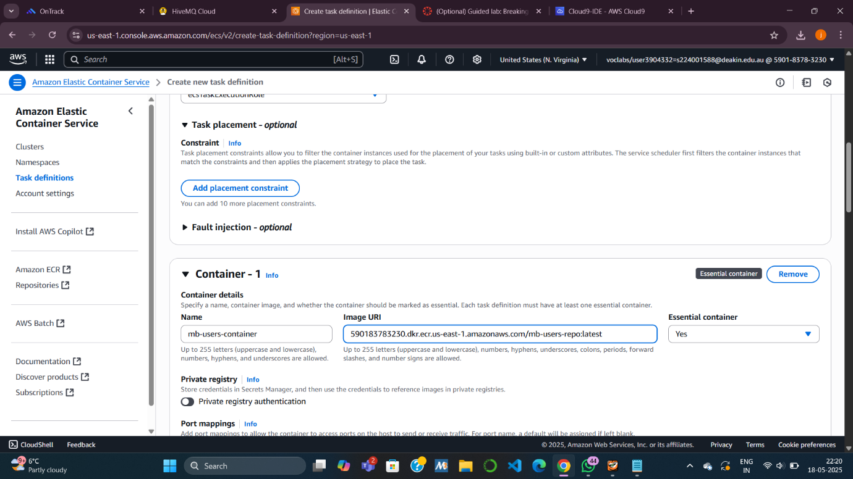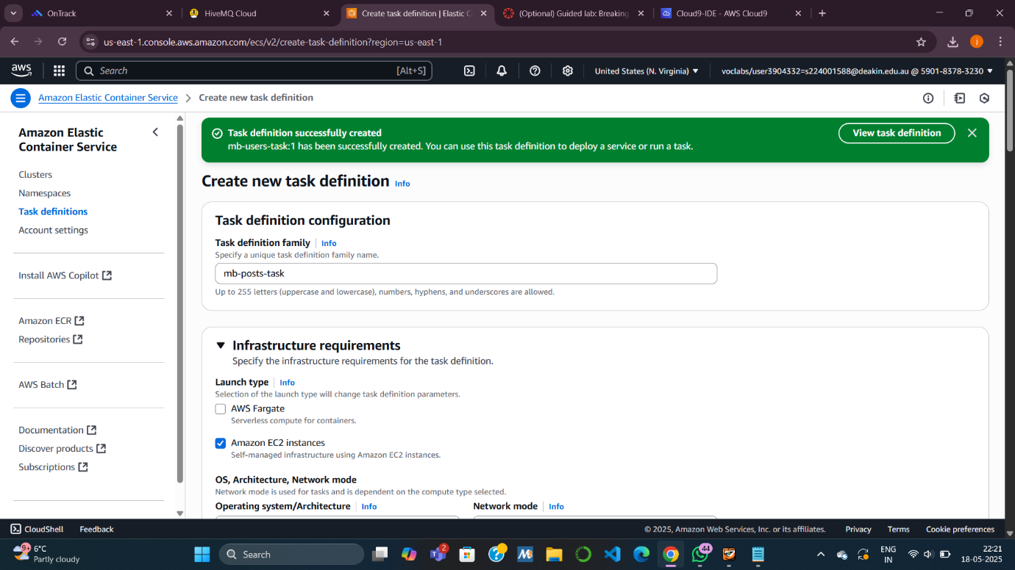

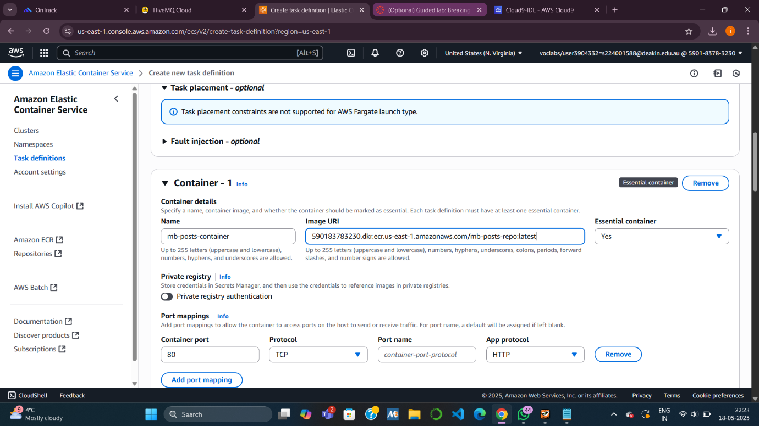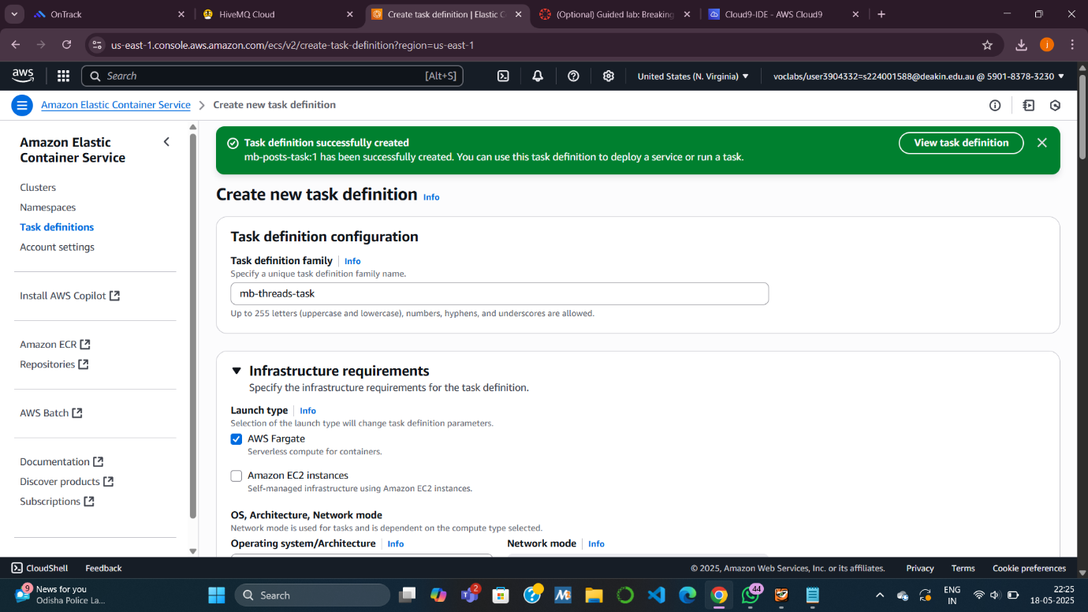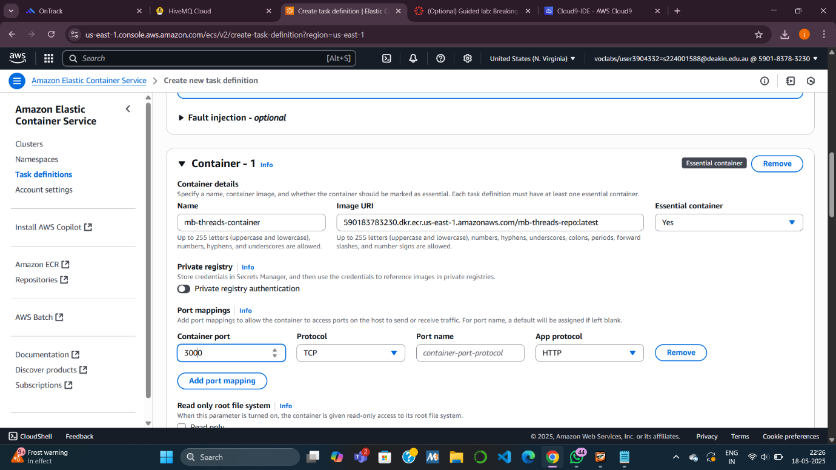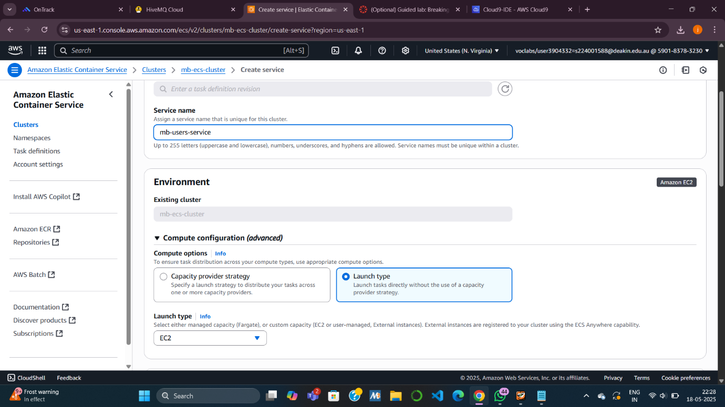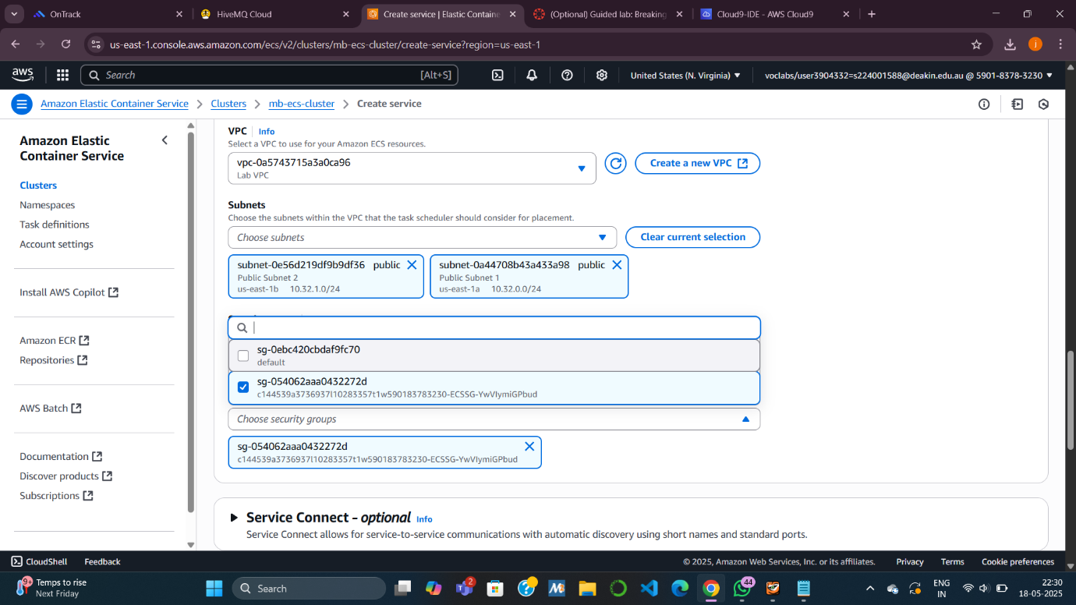

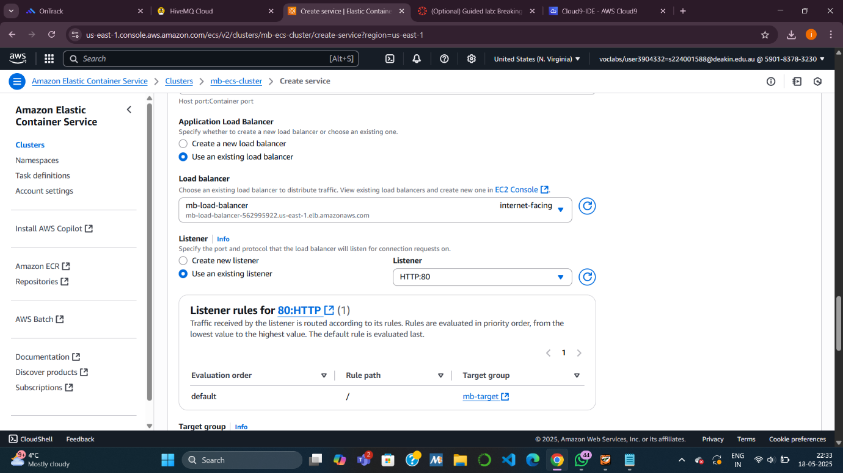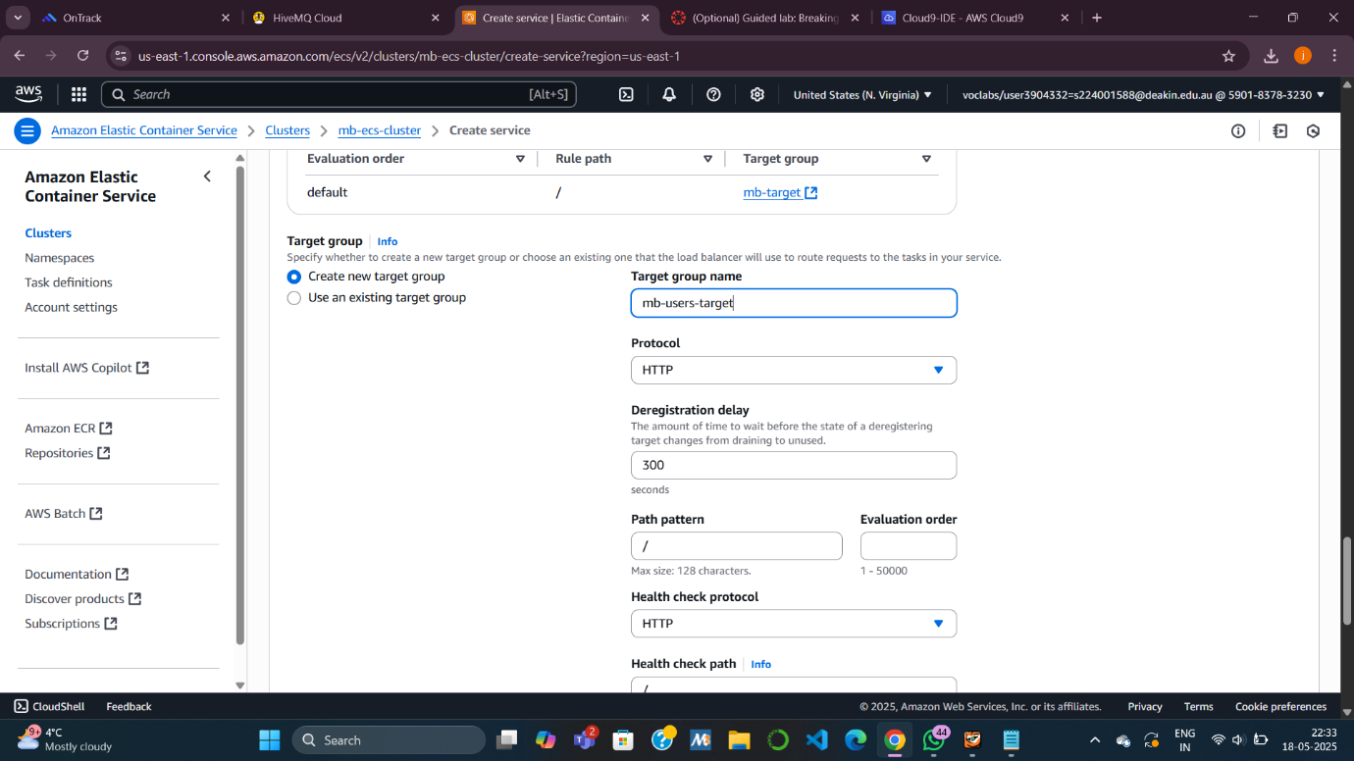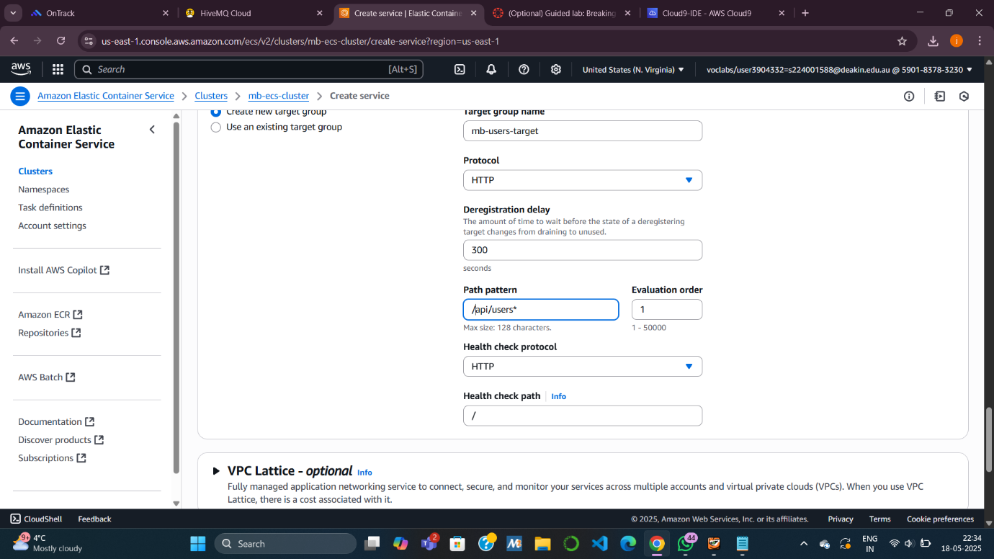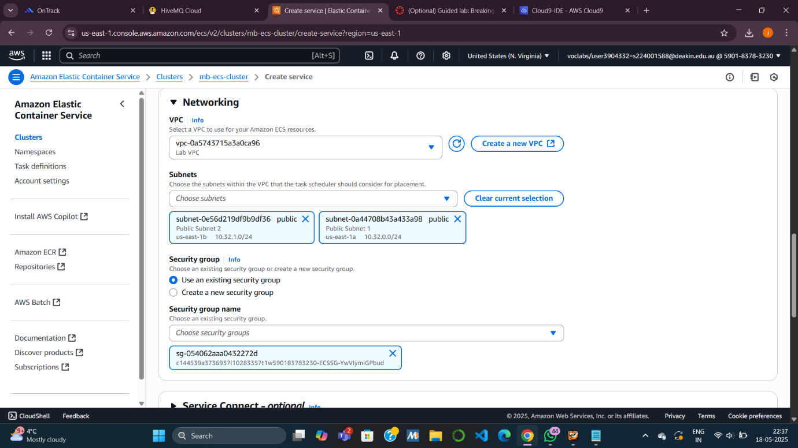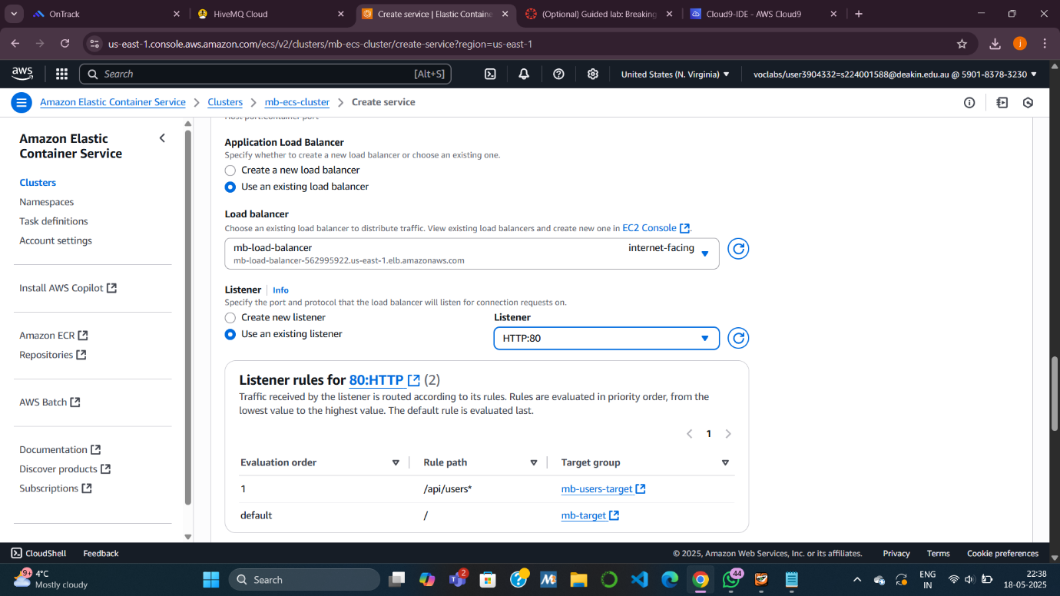

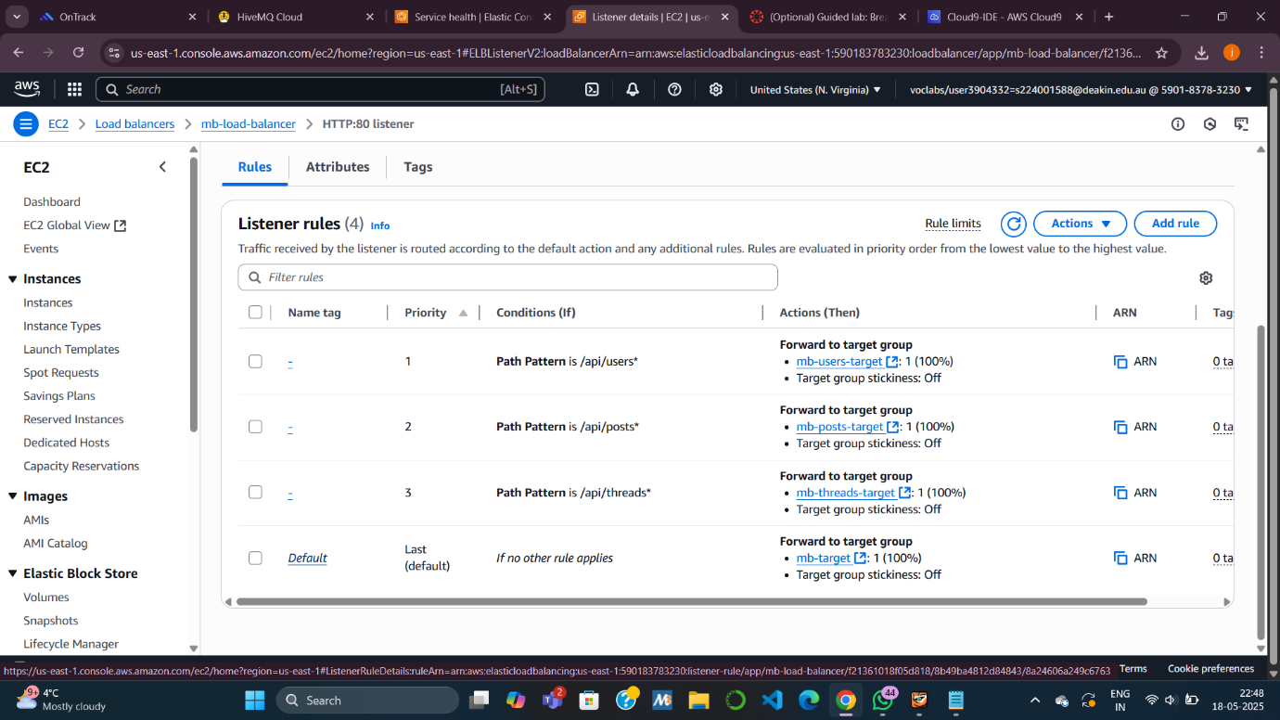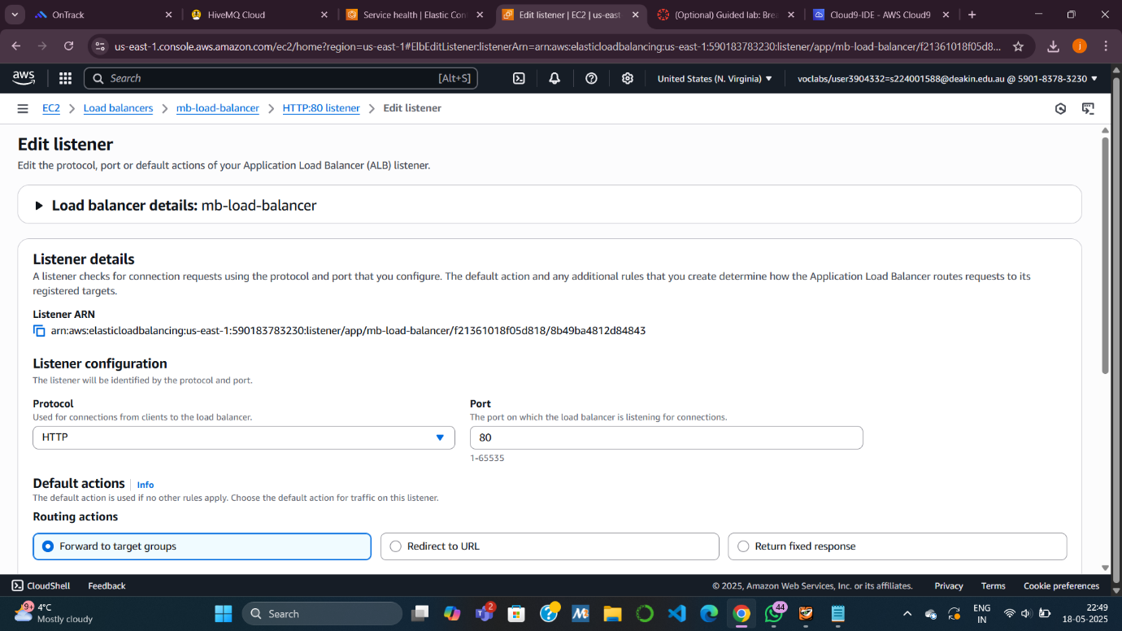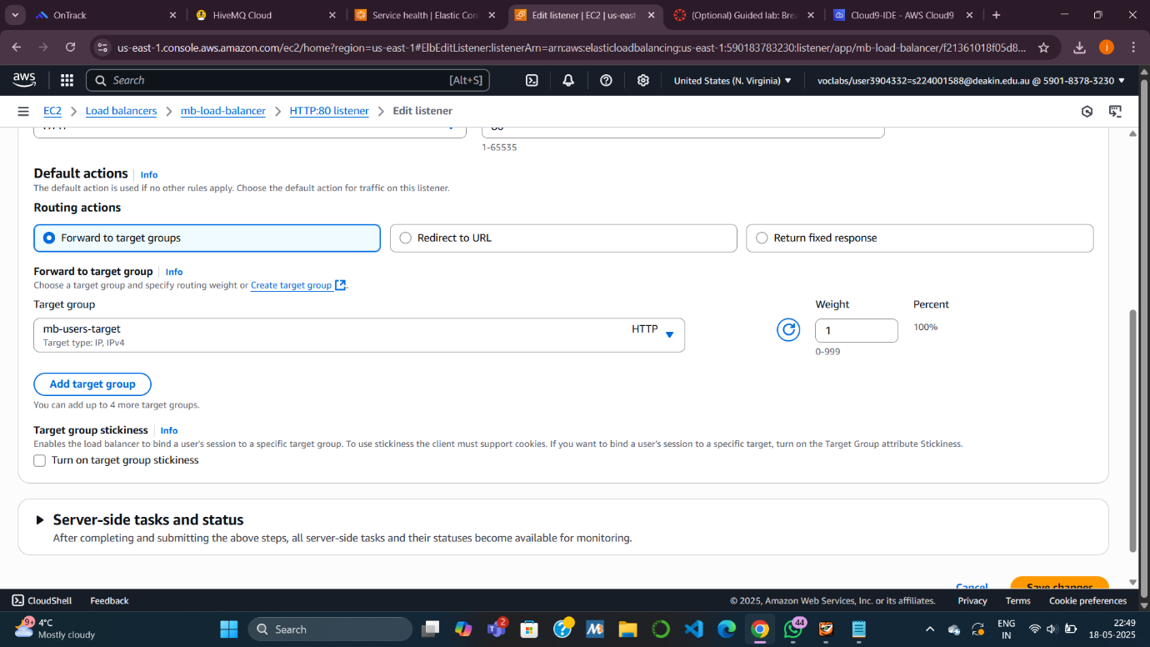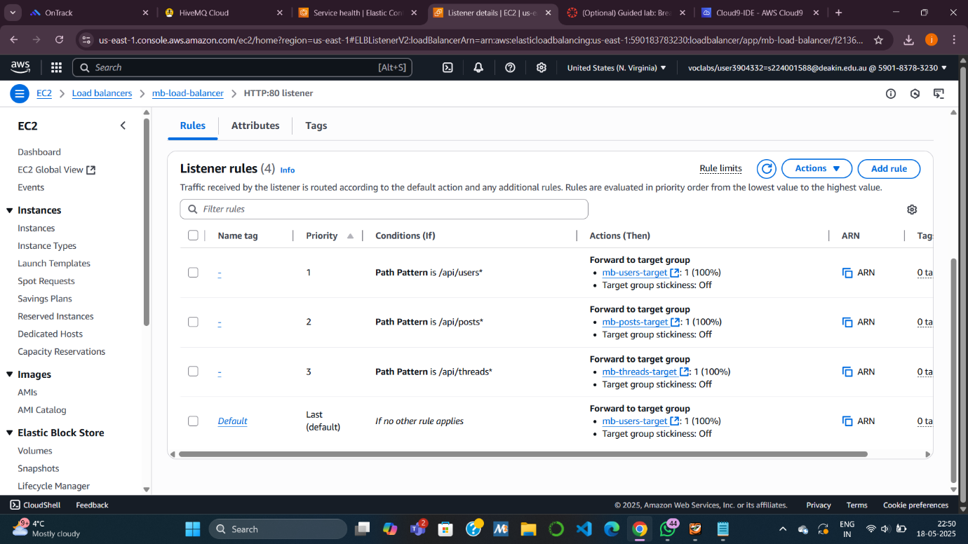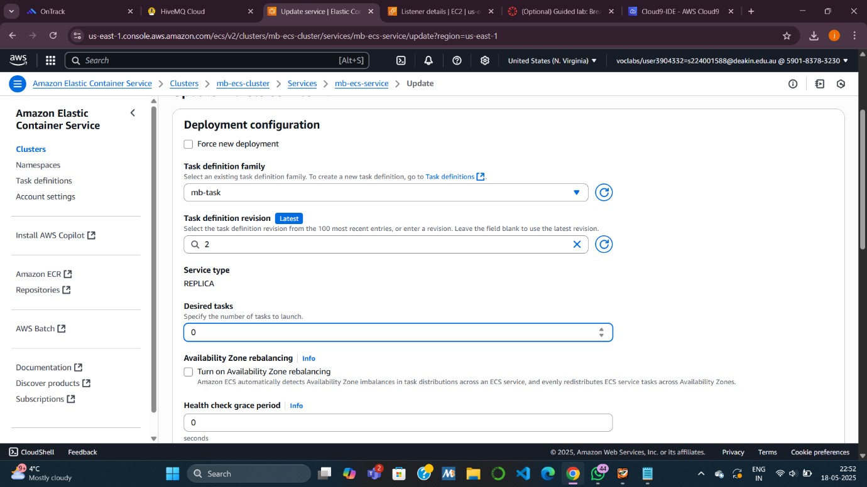

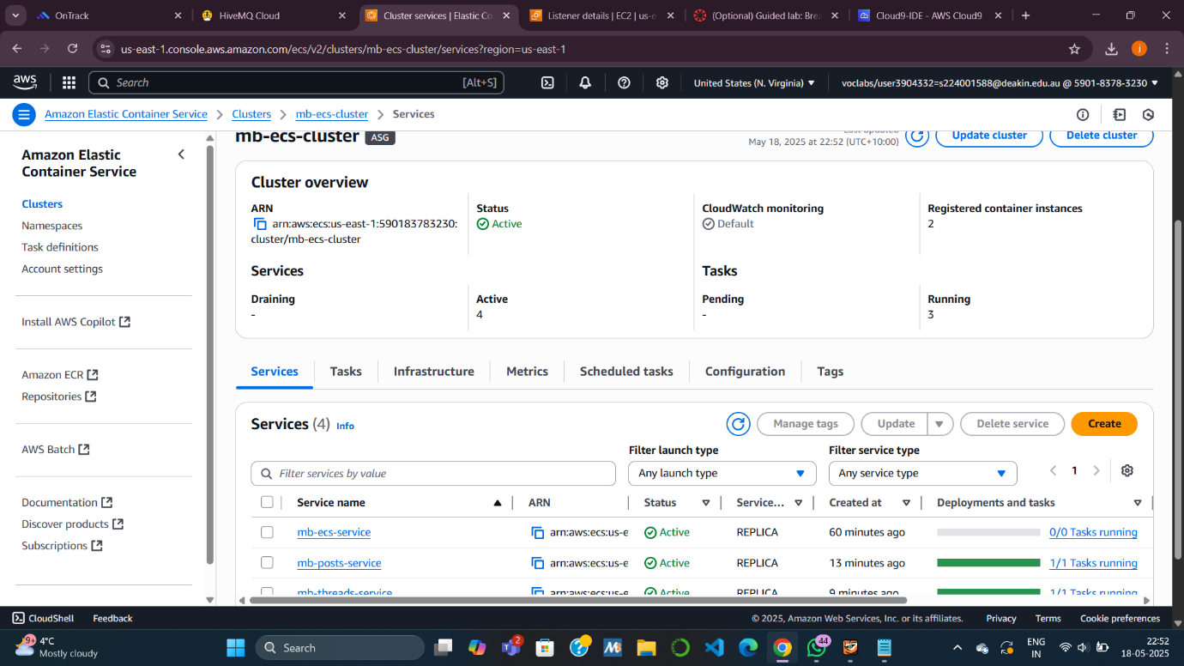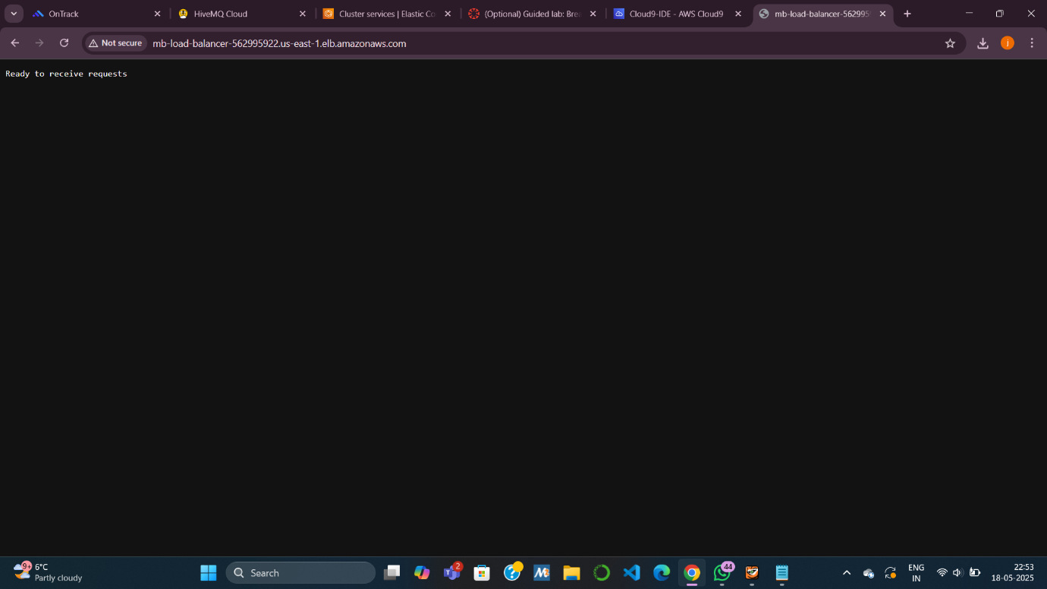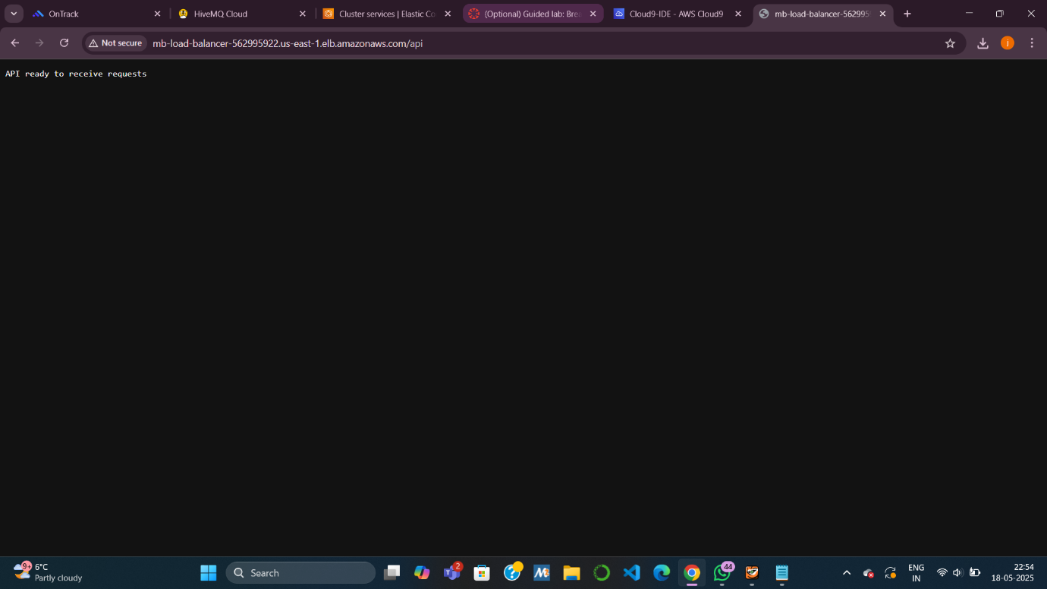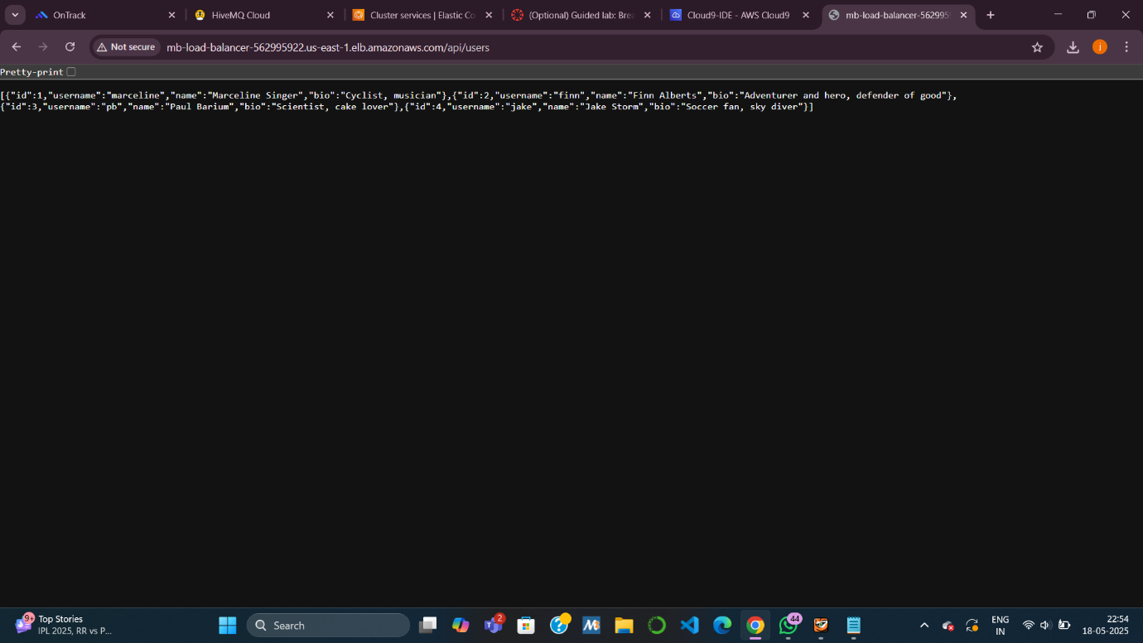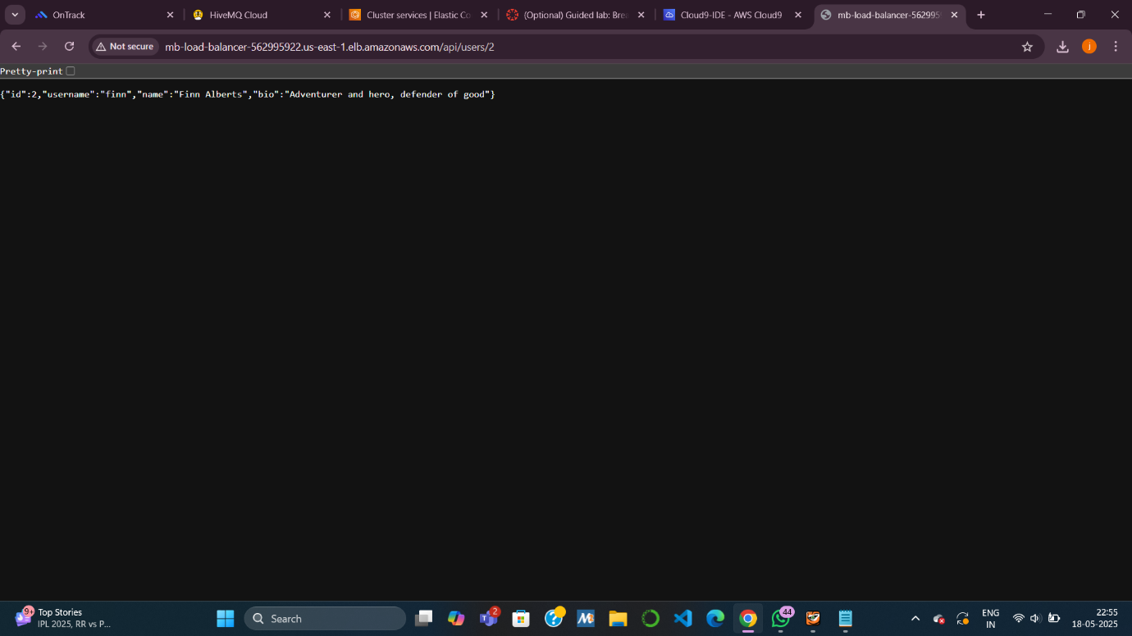

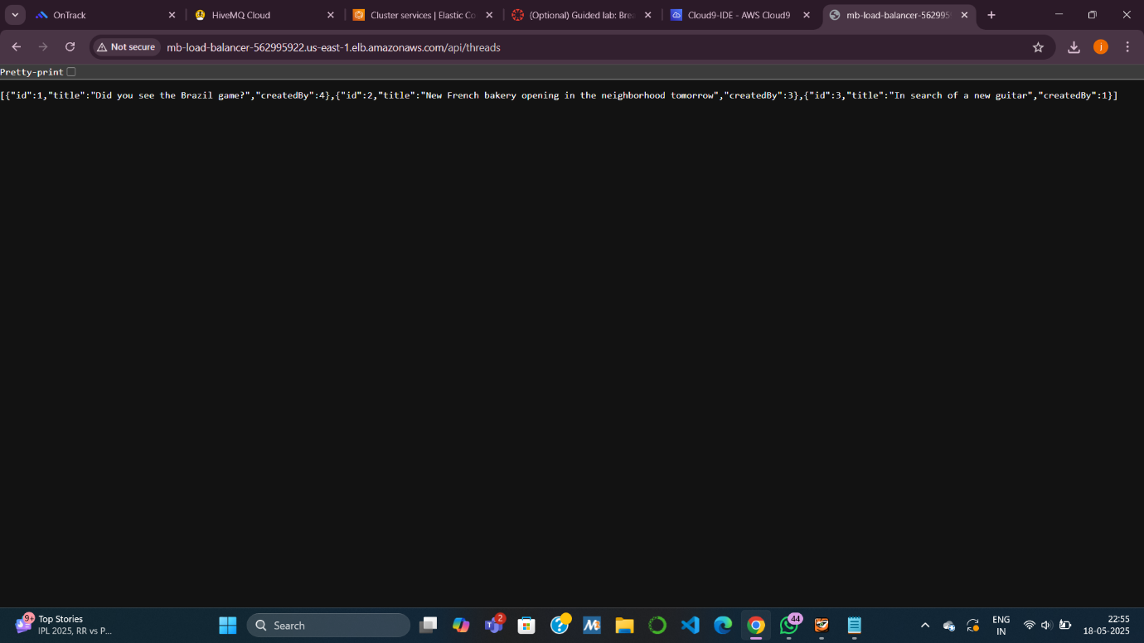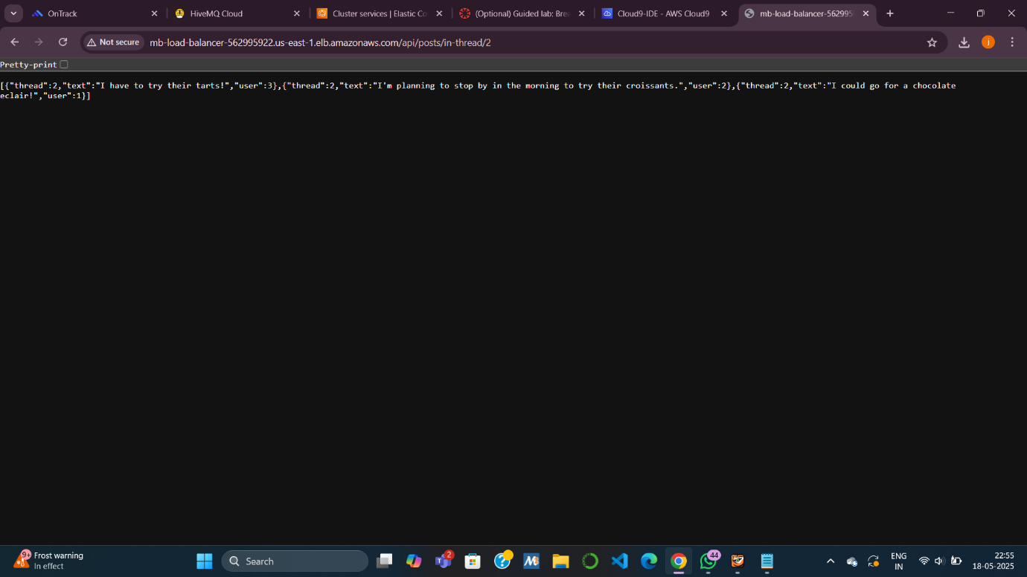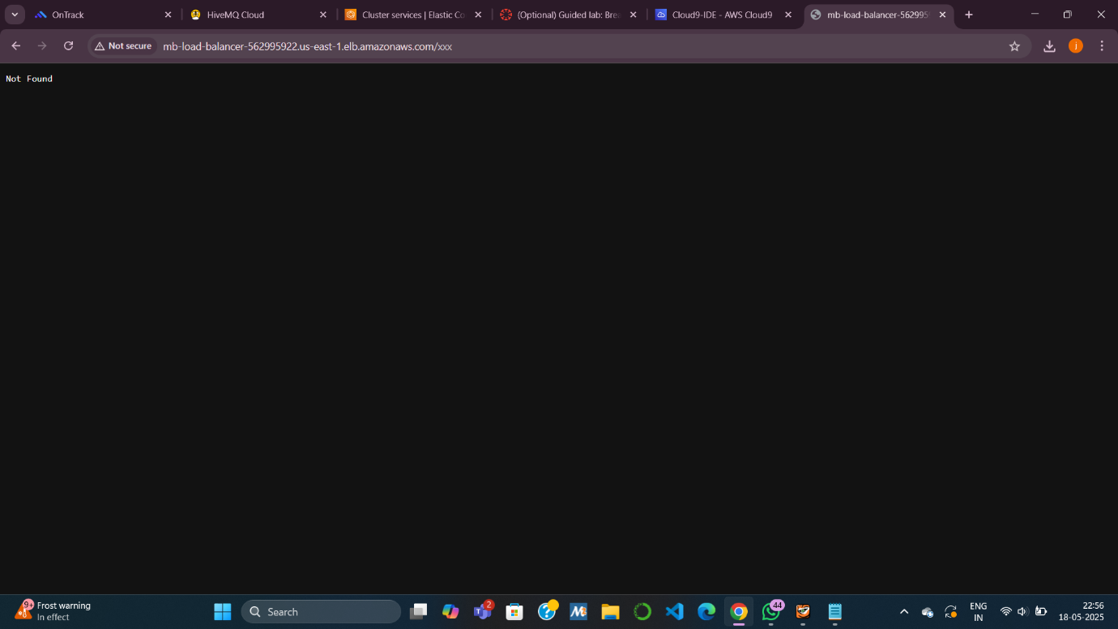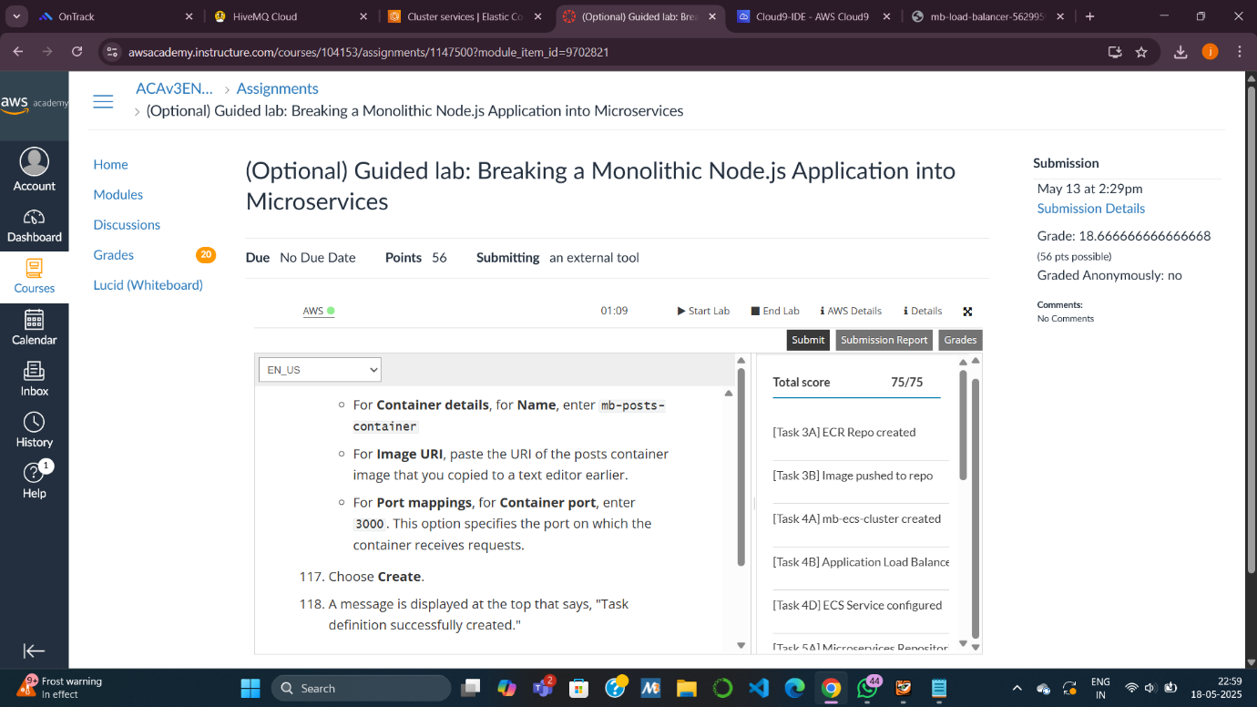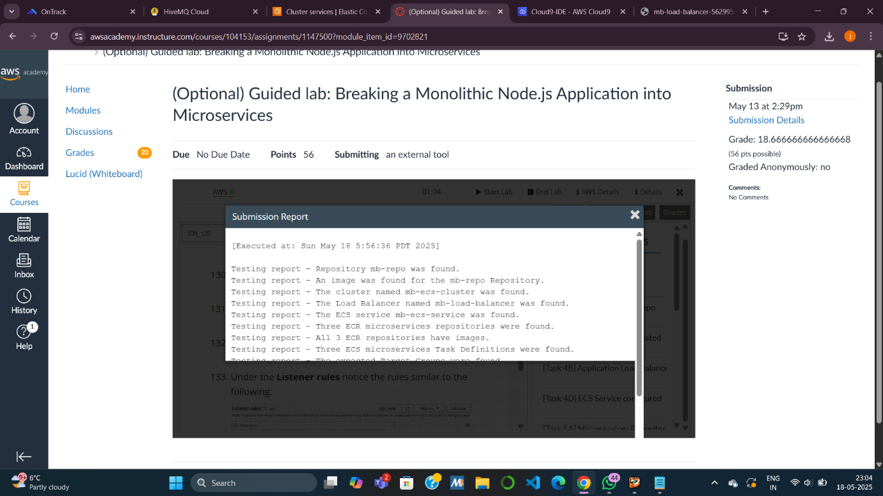

**1. What is the difference between a monolithic and microservices architecture?**

* **Monolithic Architecture**:
  + All application components (e.g., user handling, threads, posts) are packaged into a **single unit**.
  + Deployed as one service — if one component fails, it can affect the whole app.
  + Difficult to **scale** or **update individual parts** without affecting others.
* **Microservices Architecture**:
  + Application is broken into **independent services**, each responsible for one function (e.g., a separate service for users, posts, and threads).
  + Each service is **deployed, scaled, and updated independently**.
  + Easier to maintain and allows for faster innovation.

**2. What is a container and how does it differ from virtual machines (VMs)?**

* **Container**:
  + A lightweight, portable unit that packages **app code and its dependencies**.
  + Shares the **host OS kernel** but runs in isolated environments.
  + Starts quickly and uses fewer system resources.
  + Common tool: **Docker**
* **Virtual Machine (VM)**:
  + Emulates a **full operating system** (OS) with its own kernel.
  + Requires a **hypervisor** and is **heavier and slower** to start.
  + More resource-intensive than containers.

**3. What is the command used to build an image for Docker?**

docker build -t <image-name> .

Example from lab:

docker build -t mb-users-repo .

* -t specifies the tag (image name).
* . indicates to use the current directory as the build context (where the Dockerfile is located).

Knowledge check

